Amogh Gupta

Delhi Public school ghaziabad  XII

DASH DRONE DELIVERY

Dash Drone Delivery

(DDD)

**Name – AMOGH GUPTA**

**Class – X11**

**Board Roll No. - 5875303**

**CERTIFICATE**

This is to certify that **Amogh Gupta** of Class **XII A1** of Delhi Public School Ghaziabad has worked under my supervision on the project titled **“Dash Drone Delivery”** and has completed it to my total satisfaction.

Signature

Mr. Mohit Saras

P.G.T(I.P.)

Delhi Public School

Ghaziabad.

**ACKNOWLEDGEMENT**

It gives us immense pleasure to express our sincere and deep feelings of gratitude to our Informatics teacher **Mr. Mohit Saras**, who has given us his invaluable moral support from time to time and helped & co-operated with us in preparation of this Project.

I am also grateful to **My Parents** and **My Sibling** for their constant help and cooperation.

**Amogh Gupta**

XII-A1

**INDEX**

SNO. TOPIC PAGE NO.

1. System Description at a Glance 5

2. Problem Description 6

3. System Requirement 7

4. Front End and Back-End 7

5. Database Design 8

6. Design View, Coding, Run View 11

7. Bibliography 50

**System Description at a Glance**

DDD (Dash Drone Delivery) is a non-commercial project that creates a link between the customer and delivery company that can be used to order delivery, track packages and update their status.

The customer can order new packages and process the whole billing. The project offers an added advantage of tracking the product other than storing profiles and ordering packages. The employees could update the status of the package as it goes through different stages of delivery. The project even offers to update the details of the customers and employees. customer can keep a track of the packages and the date of status. Also, the project gives security by keeping personal information and address separately.

**Limitations of the project: -**

1. Only one user can sign up at a time.
2. There should always be one employee in the company to assign the package for delivery .

**Problem Description**

This project is made to solve the purpose of a delivery company which can also be used by new advancing e-commerce websites and postal office. It fulfils the daily need of a delivery company. As it is very tedious and time consuming to record all the data manually in a register and do operations in it, this project makes all these processes easy by digitalizing the system.

As there is a shift in paradigm from hand written paper documents to digitalized computer programs, this project caters to these documentation needs and makes this process both easy and energy efficient.

**System Requirement**

* INTEL PROCESSOR SPEED : 500MHz
* RAM:128 MB FOR CLIENT AND 512 MB FOR SERVER.
* WINDOWS 98/XP/2000/NT/ANY OTHER HIGHER VERSION.
* J2SE PLATFORM 6.0,5.0 UPDATE 9/13.
* JAVA DEVELOPMENT KIT.
* INTEGRATED DEVELOPMENT ENVIRONMENT(IDE)-NET BEANS.
* MySQL VERSION FOR WINDOWS (x86).(MySQL 4.0 OR 5.0 OR HIGHER).
* MySQL JDBC DRIVER.

**Database Design**

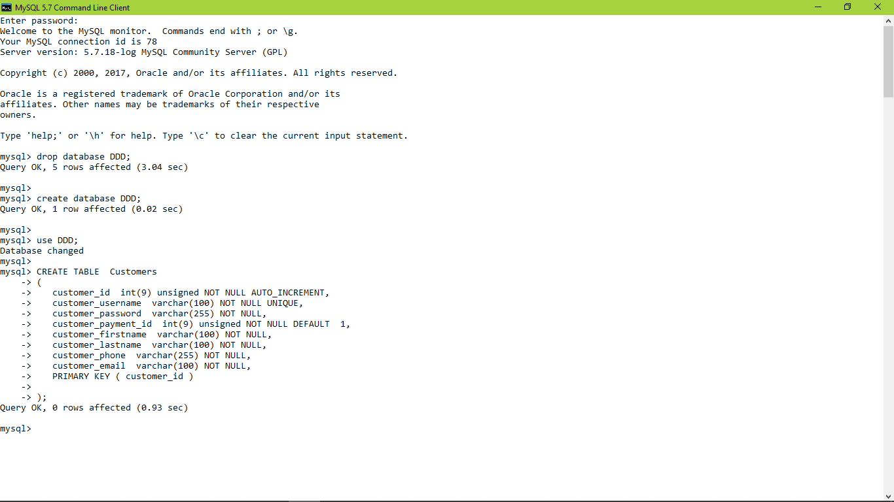

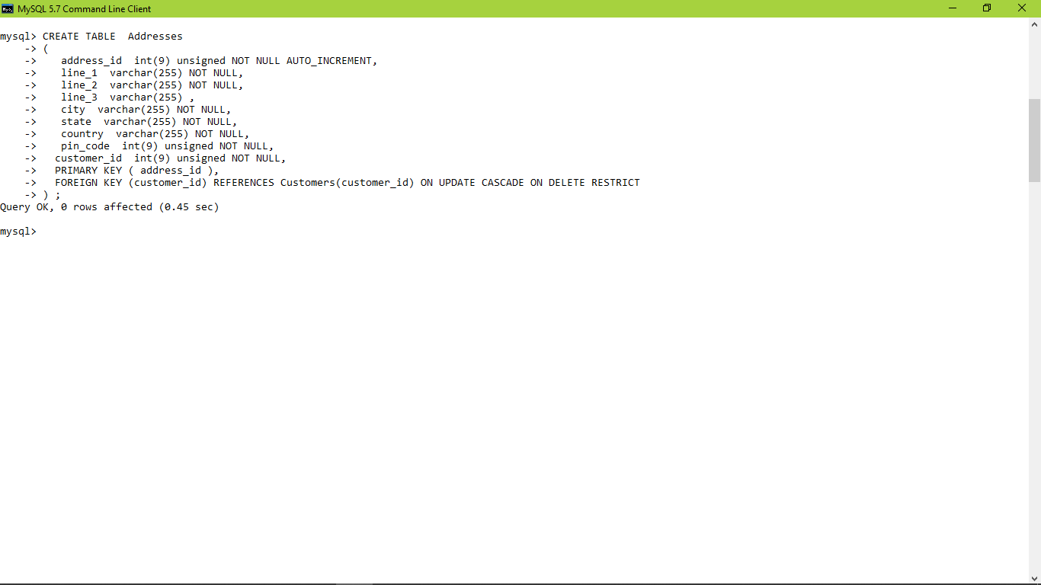

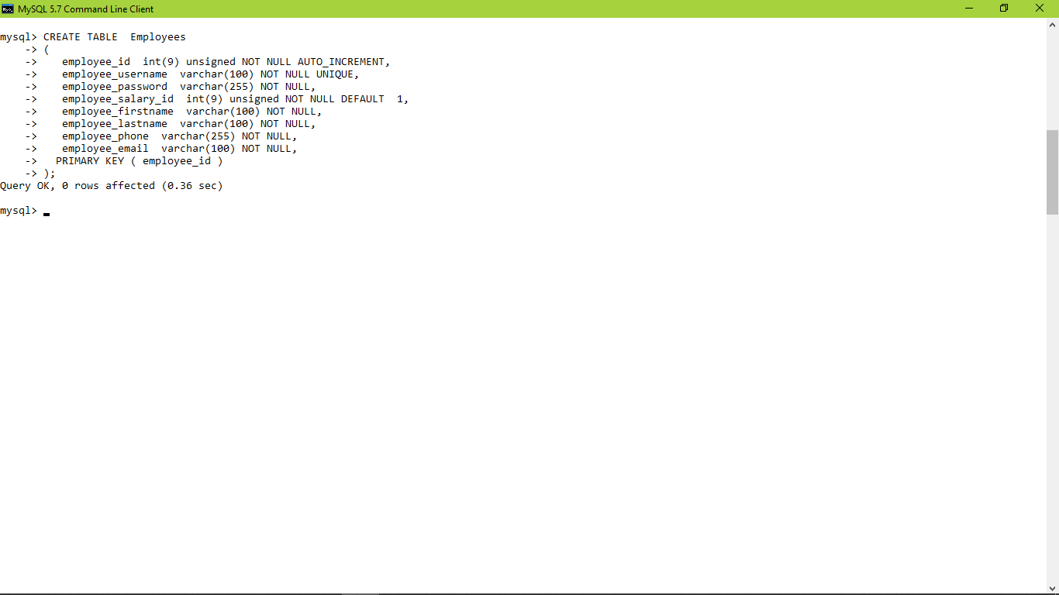

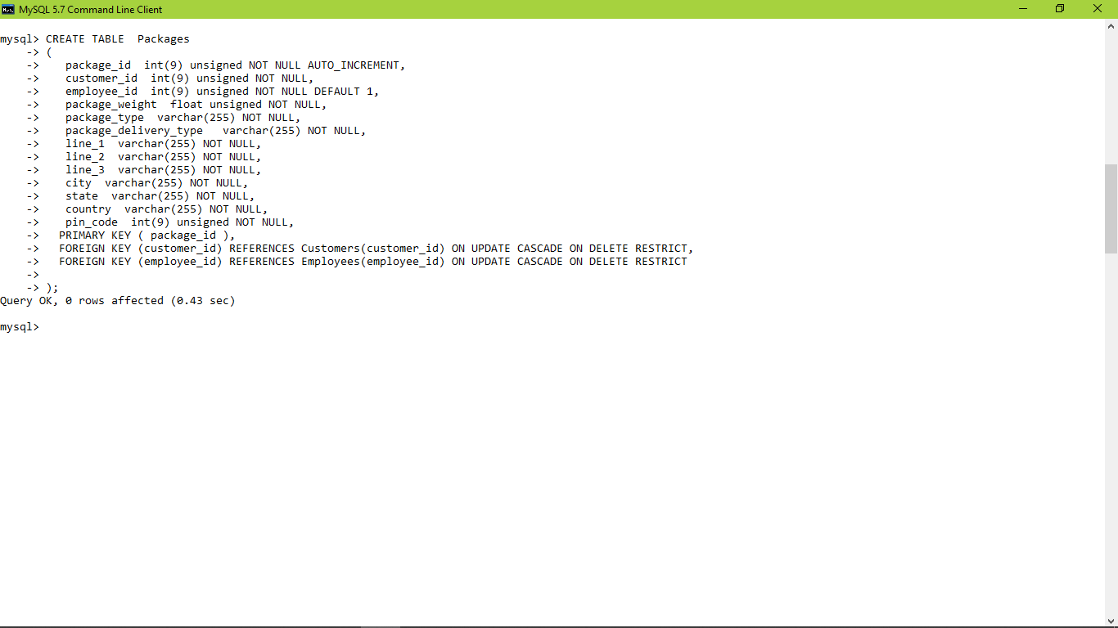

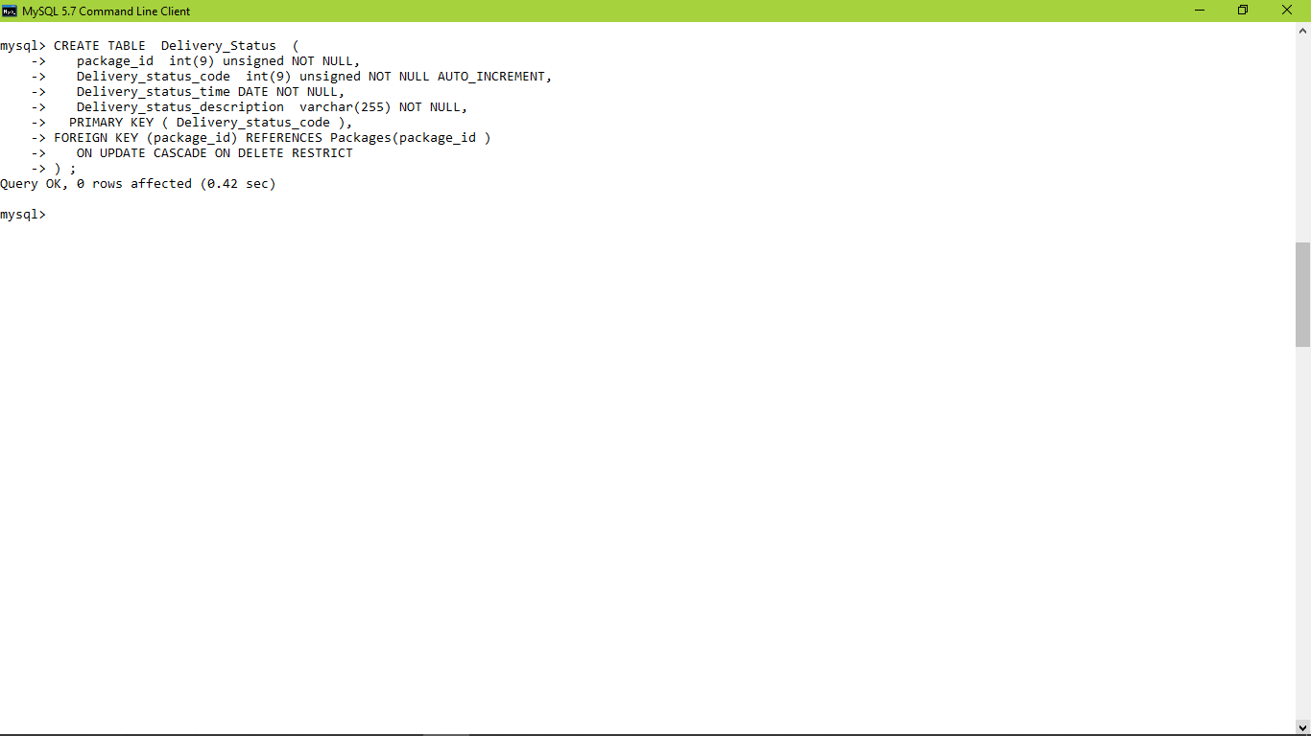

**DESIGN VIEW , CODING , RUN VIEW**

Design View :

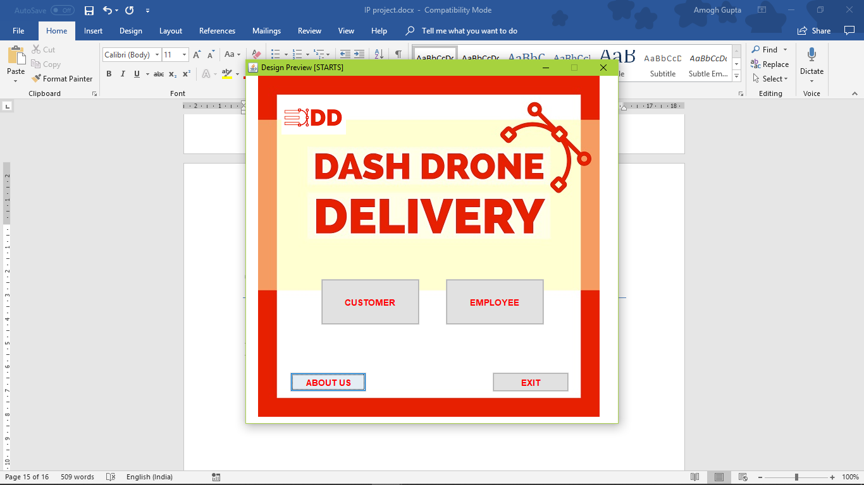

Action Performed (EMPLOYEE) :

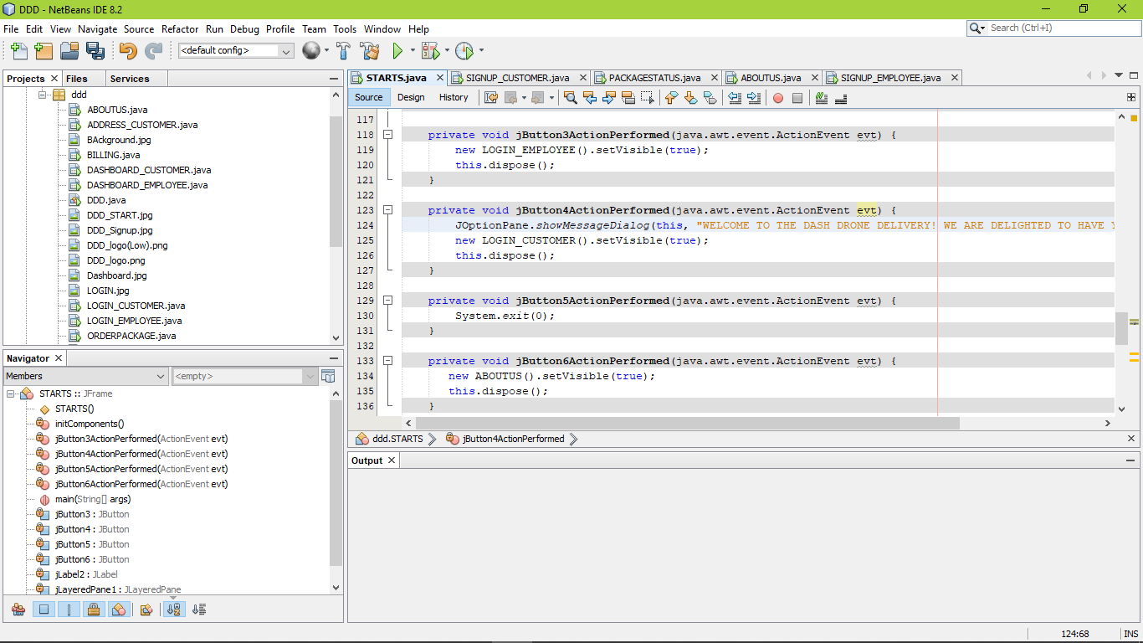

Action Performed (CUSTOMER):



Action Performed (ABOUT US):



Action Performed (EXIT):



Run View :

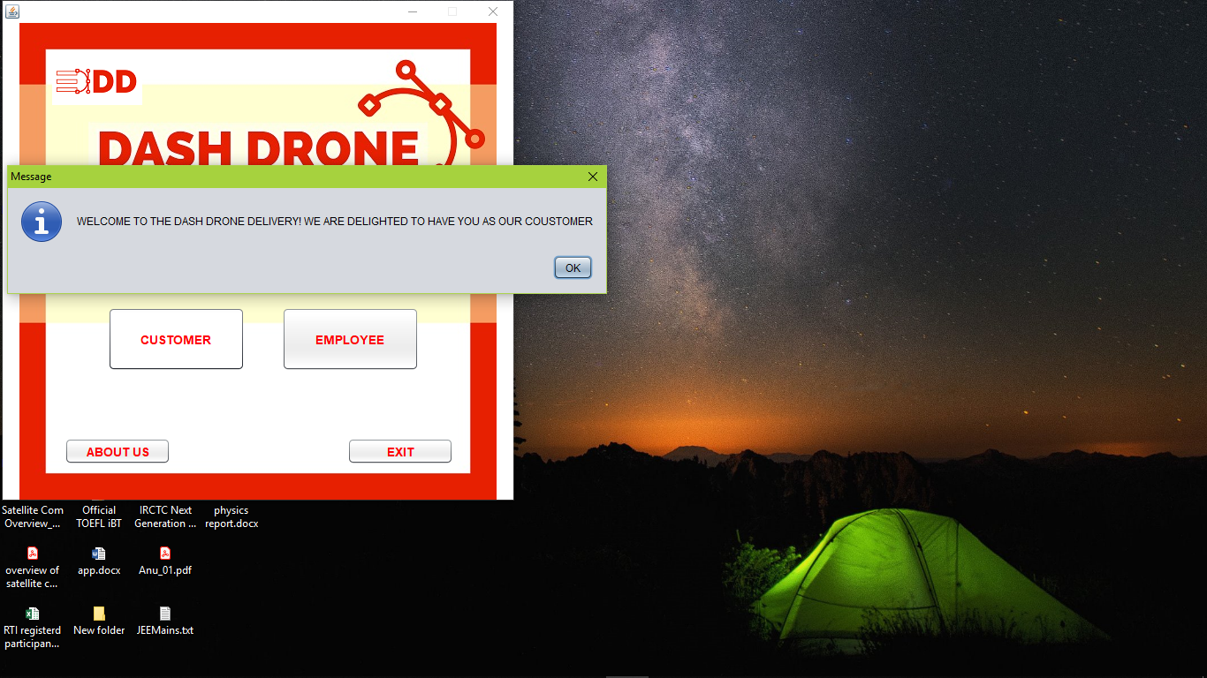

Design View (LOGIN_ CUSTOMER):

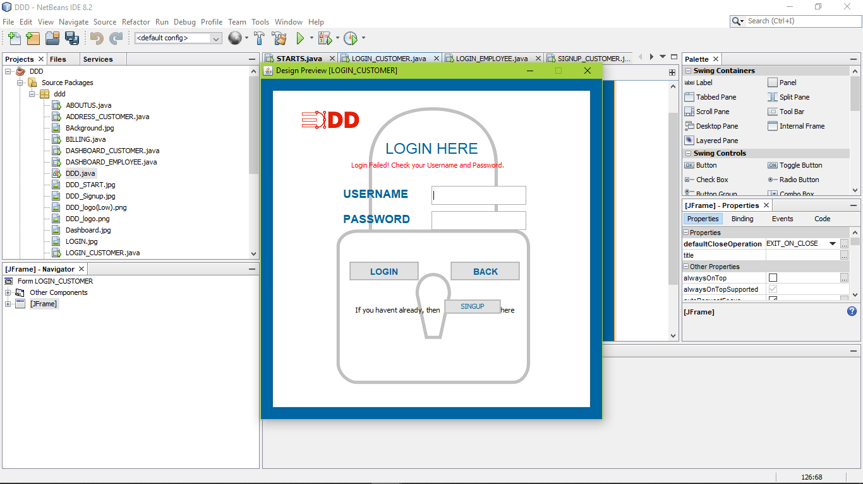

Action Performed (LOGIN):

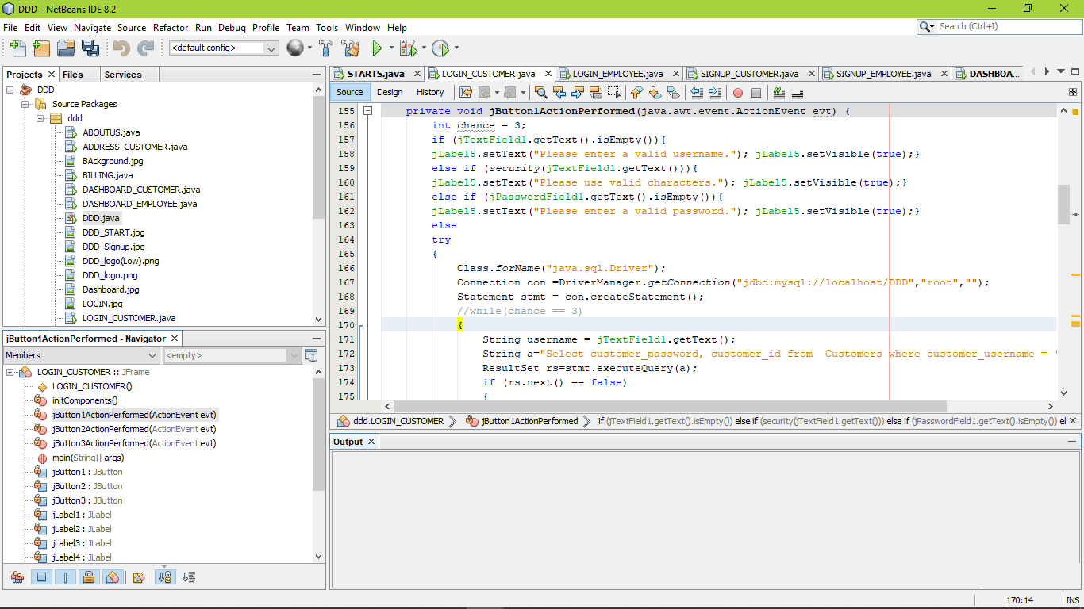

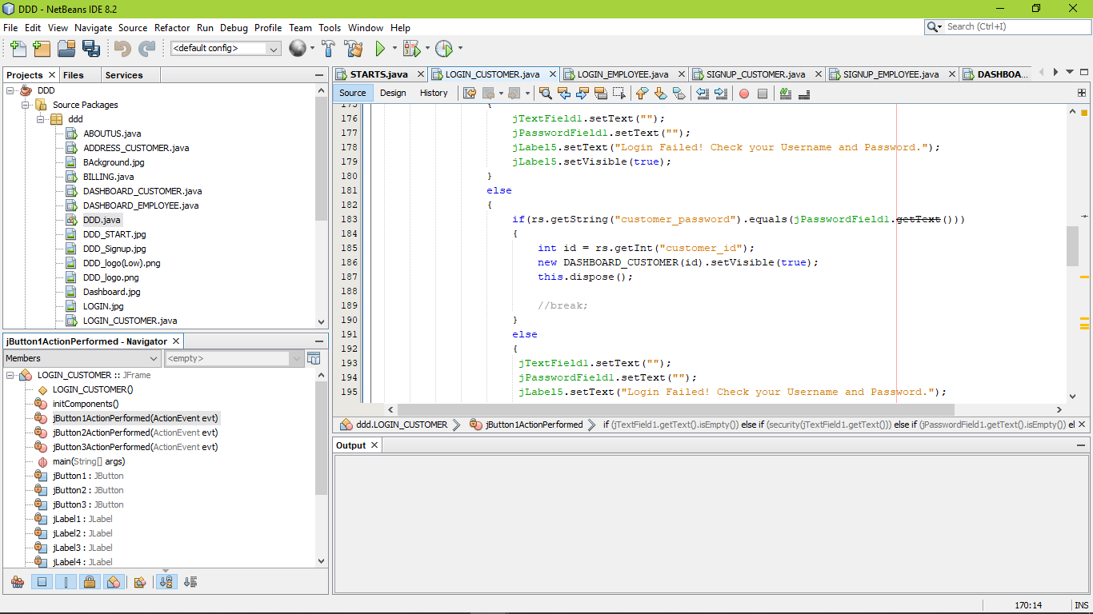

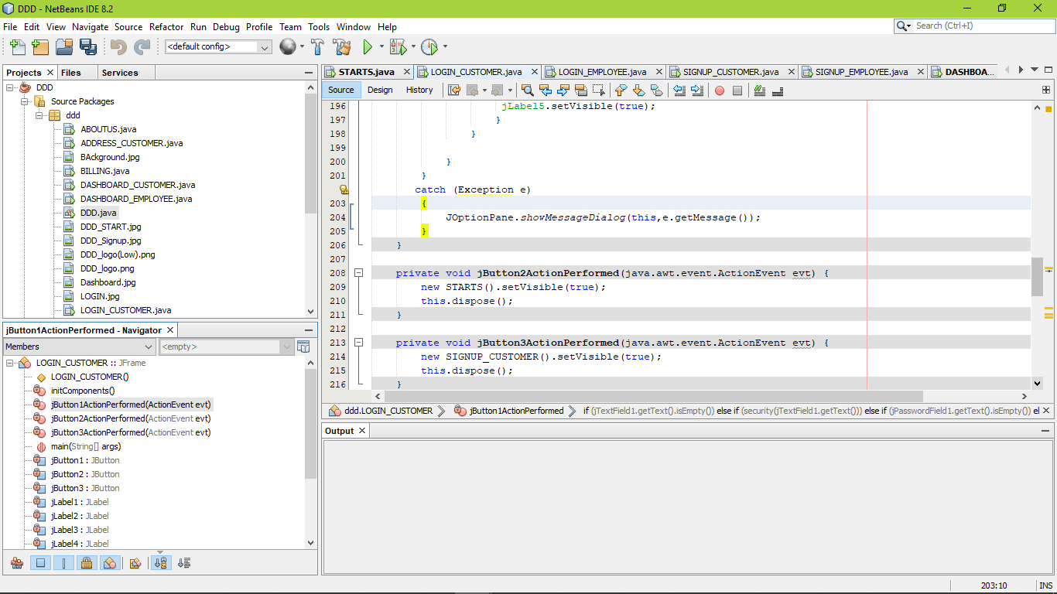

Action Performed (BACK):



Action Performed (SIGN UP):



Design View (SIGN UP CUSTOMER):

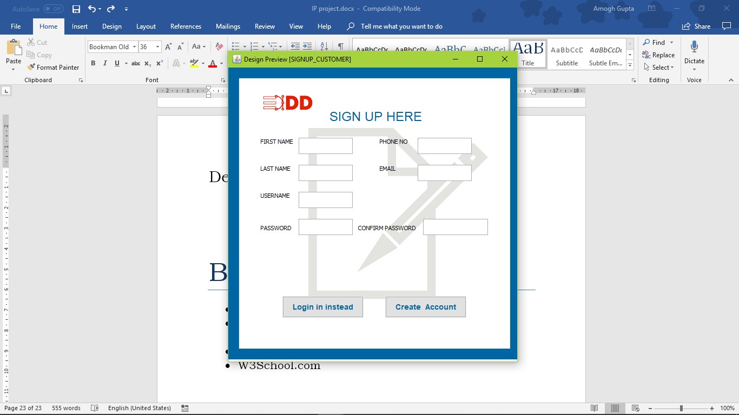

Action Performed (CREAT ACCOUNT):

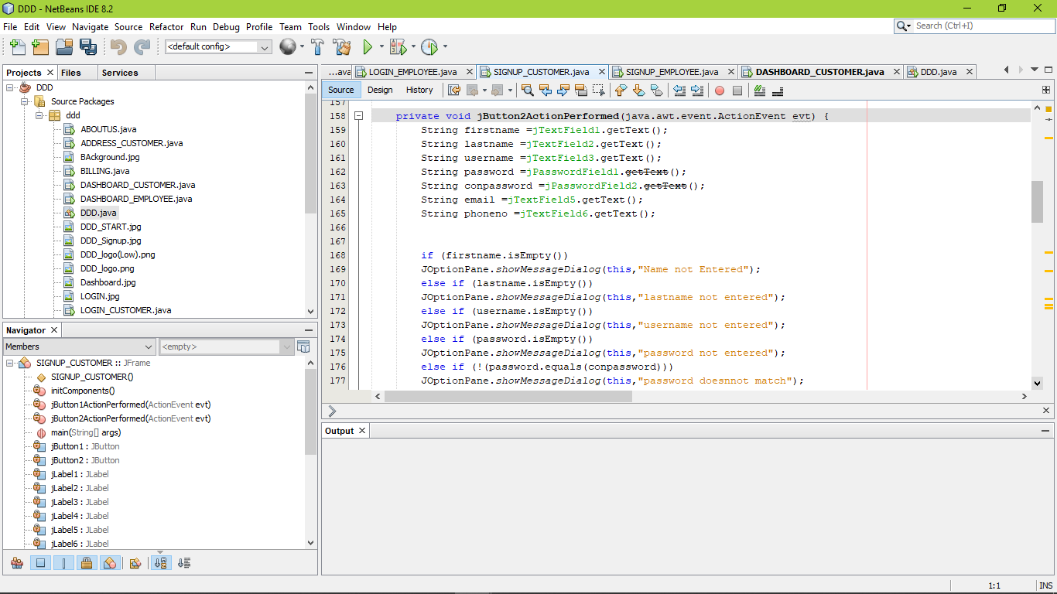

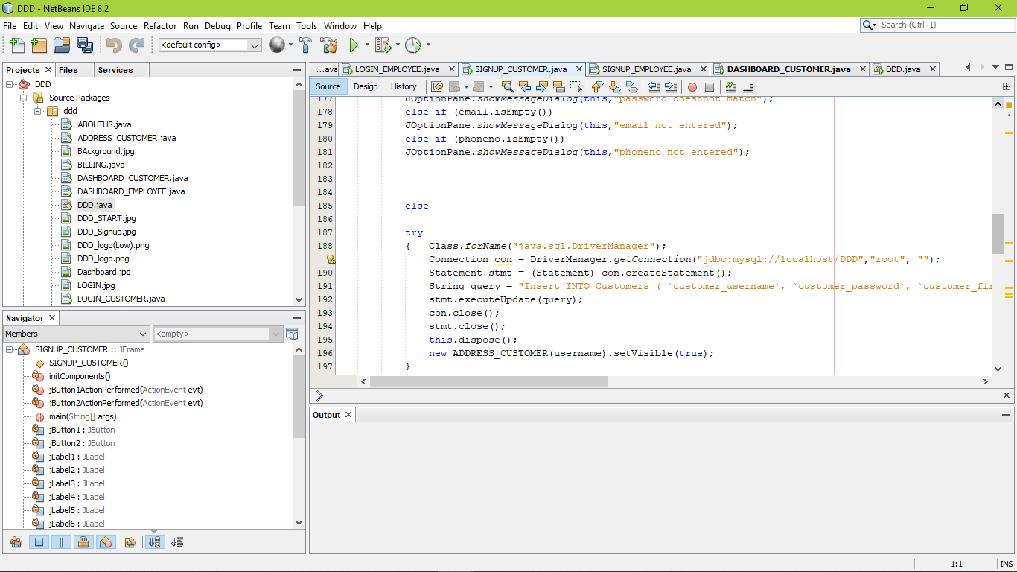

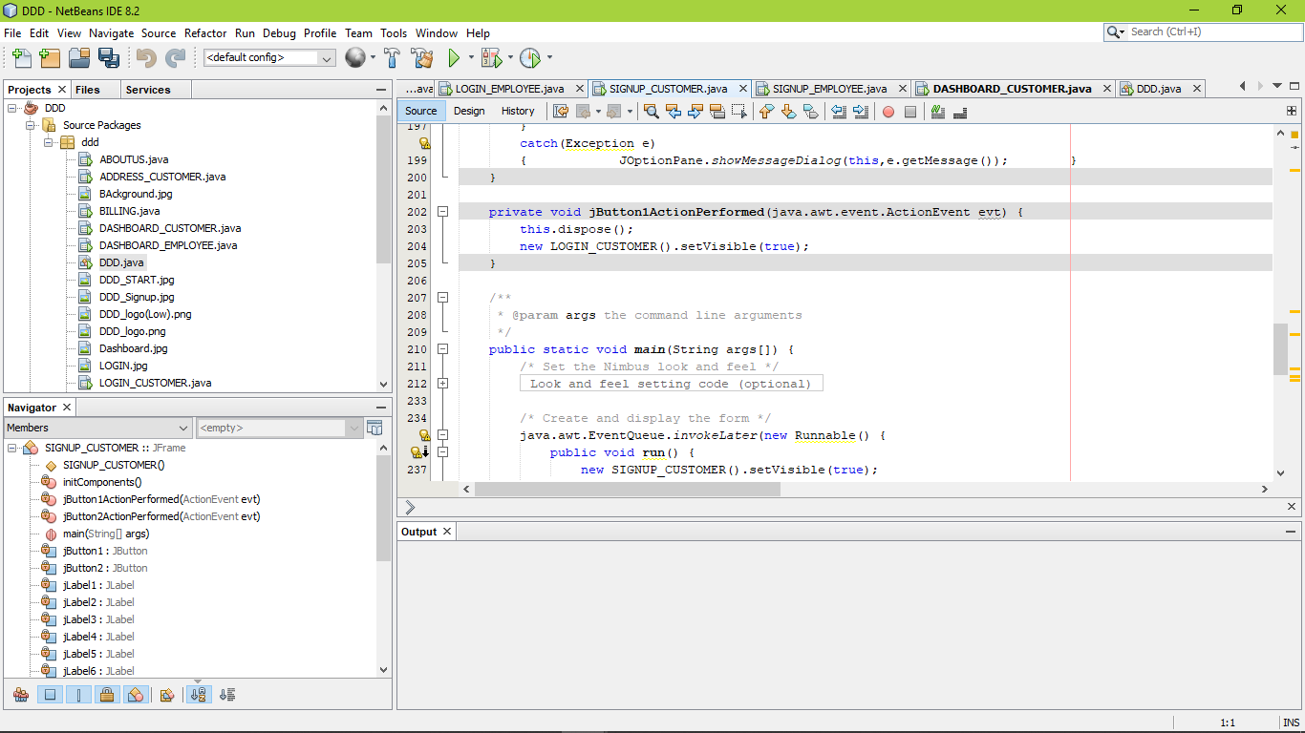

Action Performed (LOGIN INSTEAD):



Design View (ADRESS CUSTOMER):

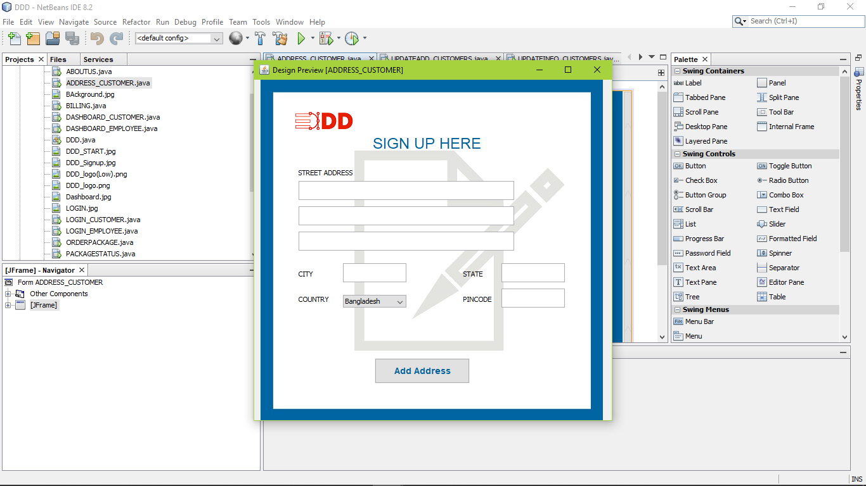

Action Performed (ADD ADRESS):

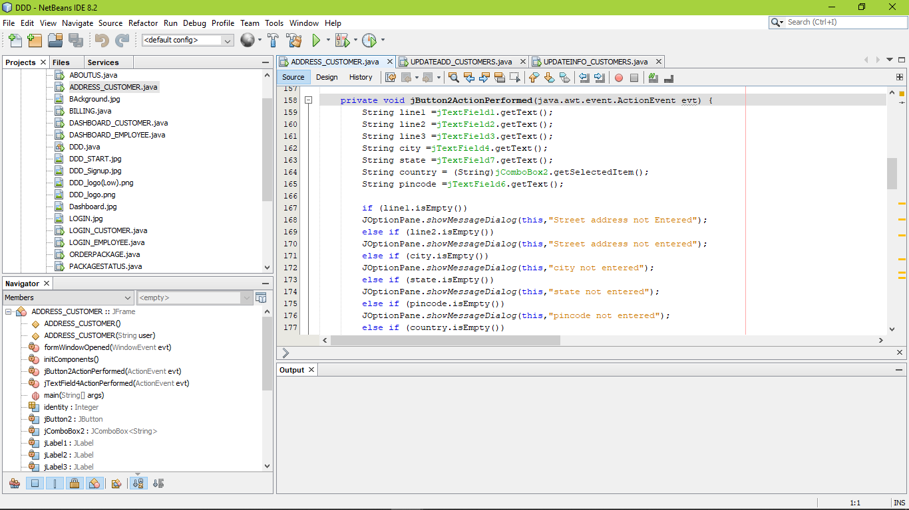

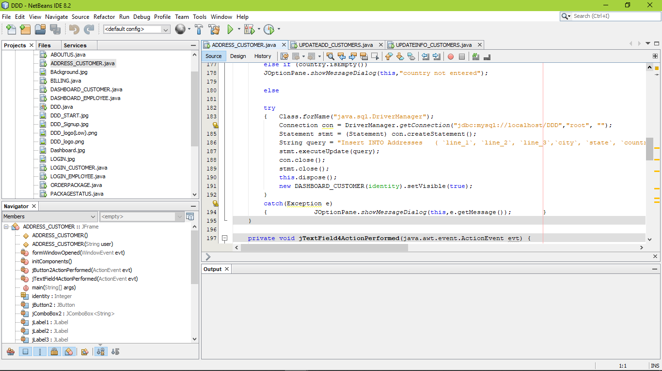

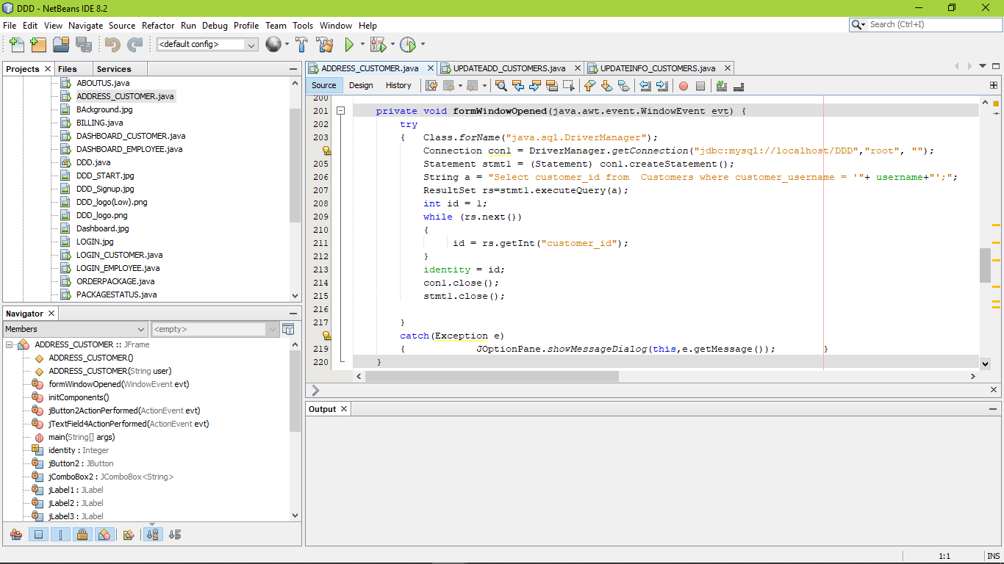

Design View (DASHBOARD CUSTOMER):

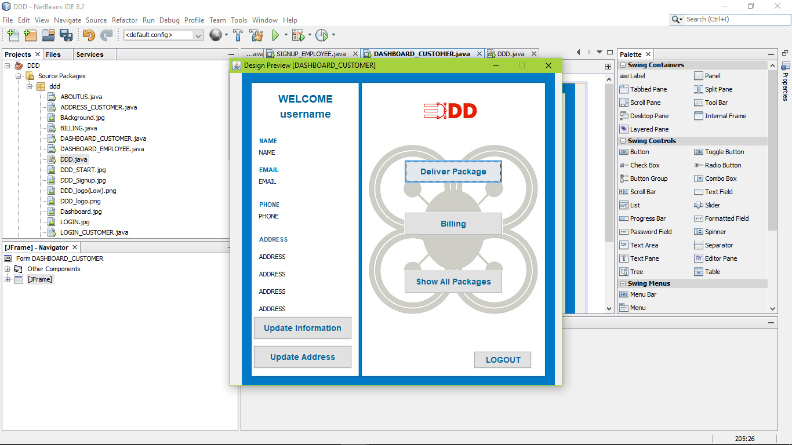

Action Performed (UPDATE INFORMATION):

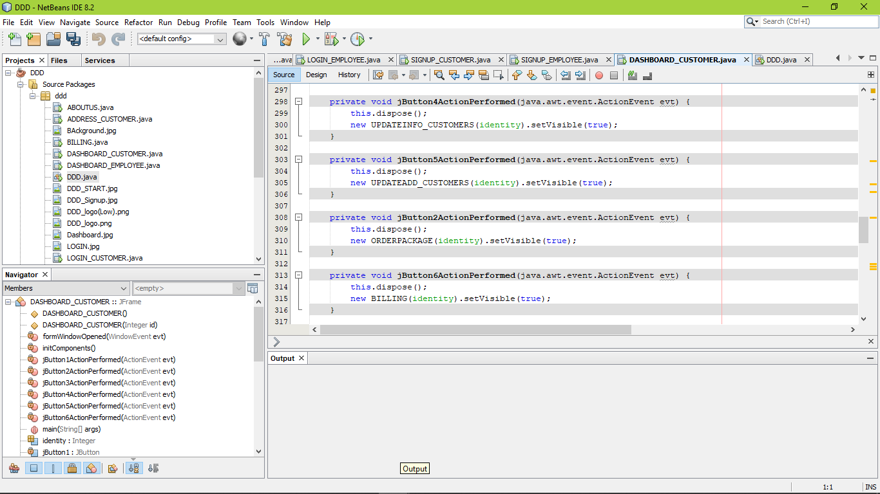

Action Performed (UPDATE ADDRESS):



Action Performed (DELIVERY PACKAGE):



Action Performed (BILLING):



Action Performed (SHOW ALL PACKAGE):

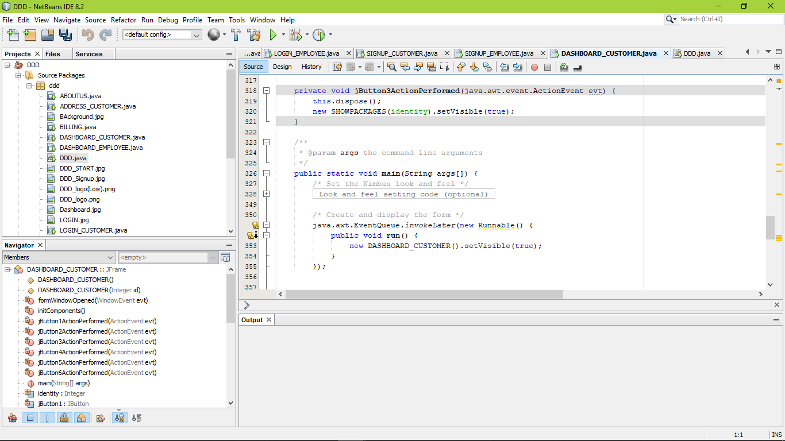

Run View :

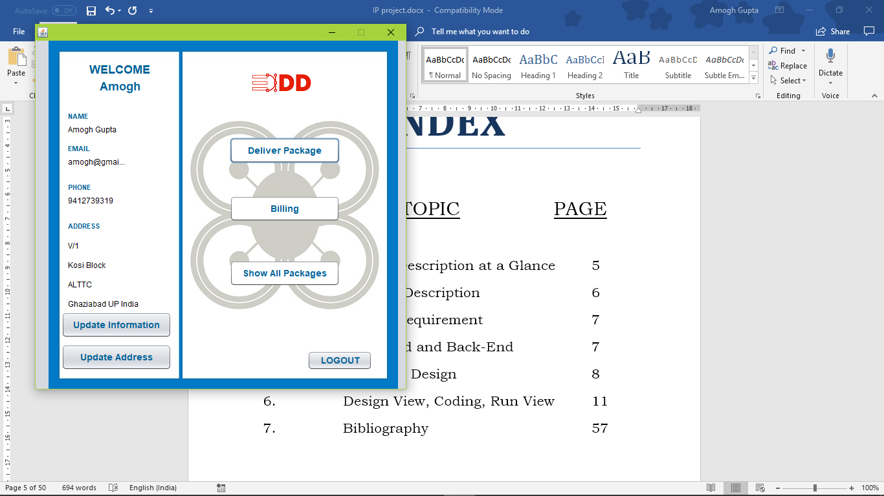

Design View (UPDATEINFO_CUSTOMER):

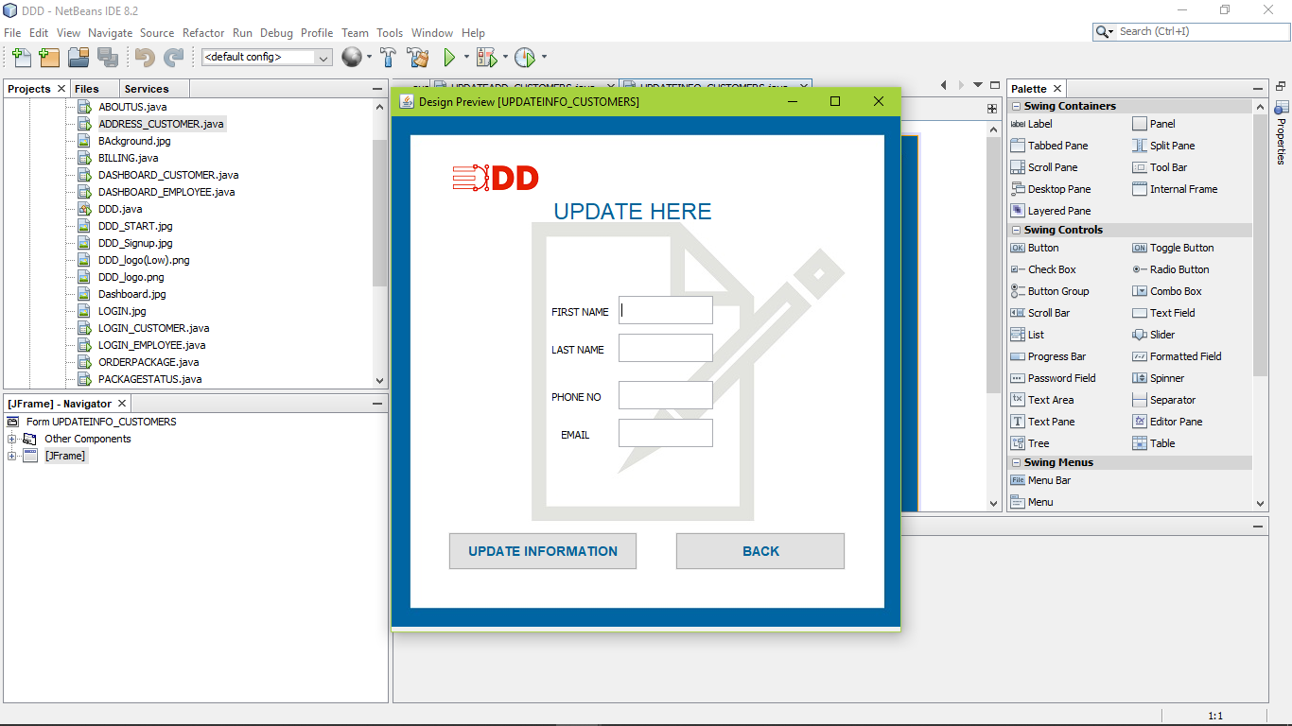

Action Performed (UPDATE INFORMATION):

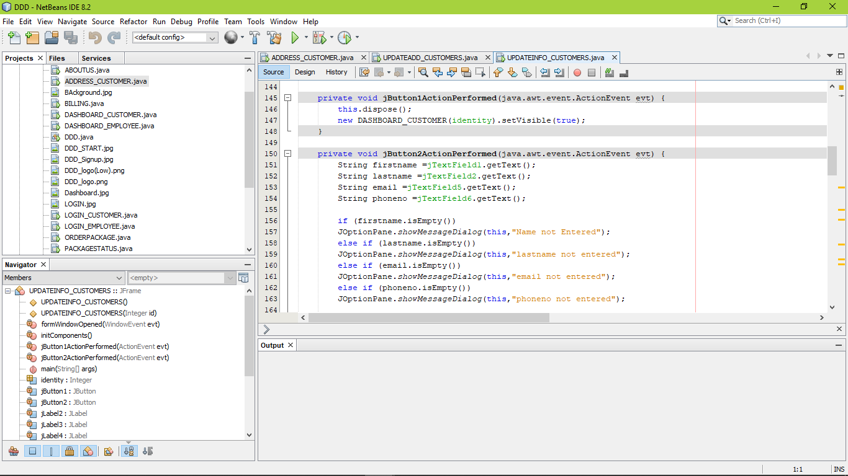

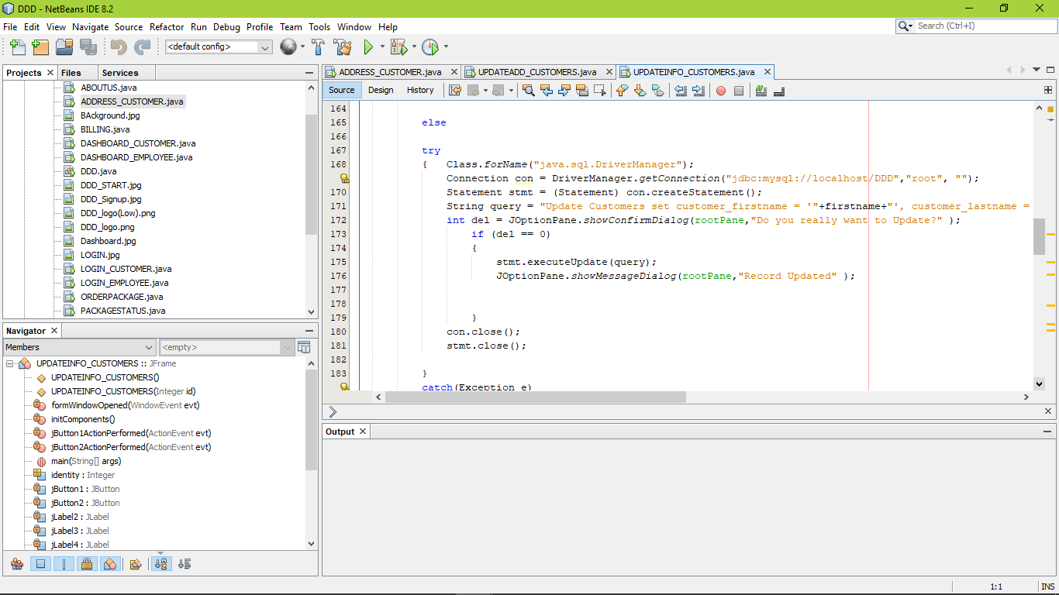

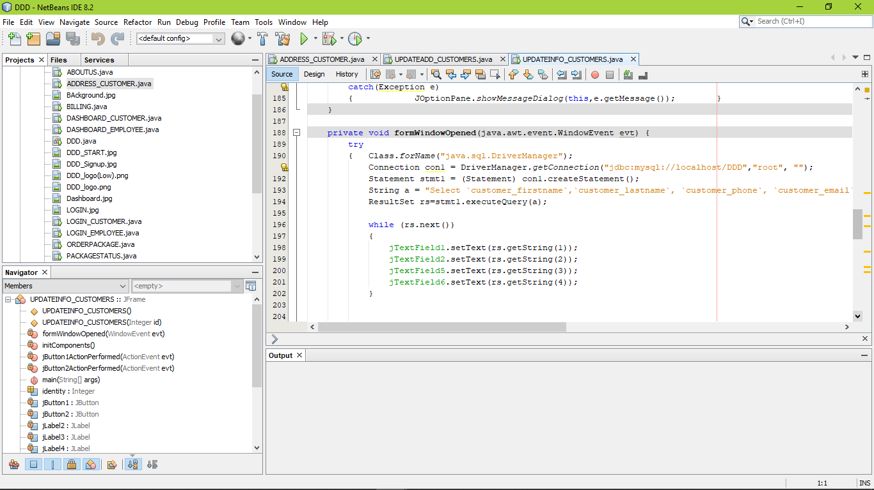

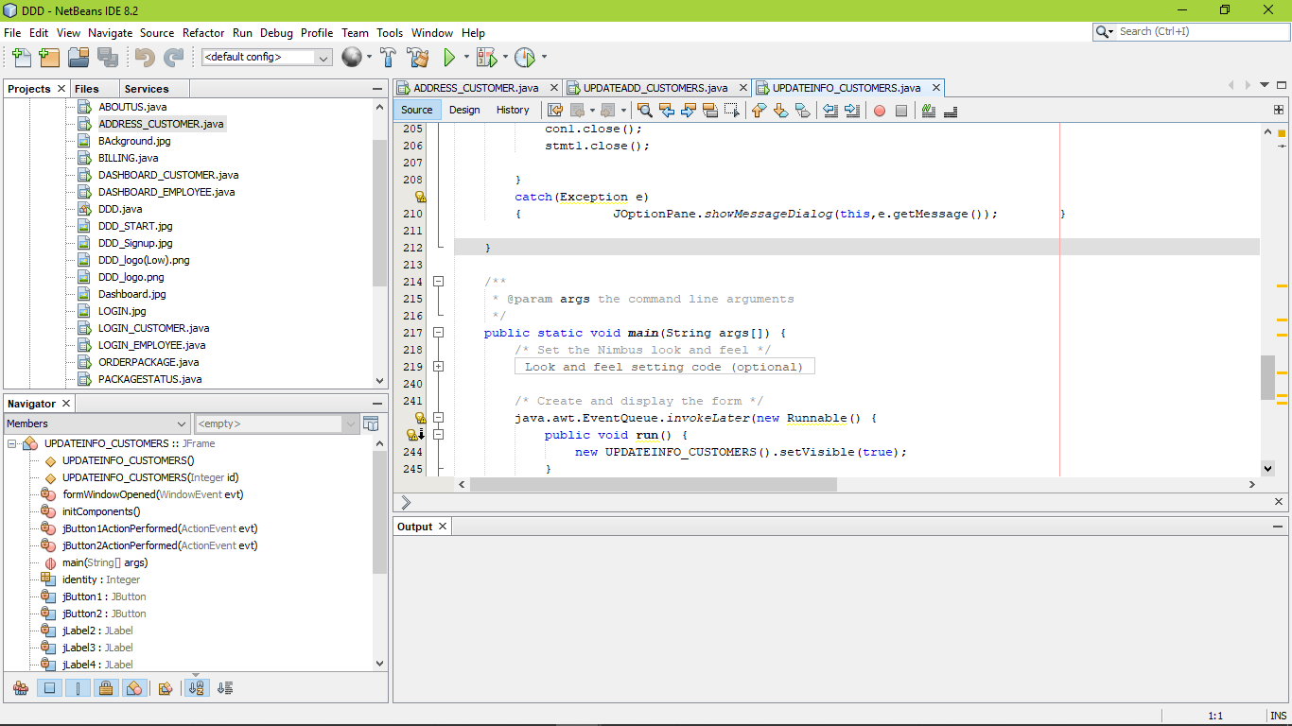

Action Performed (BACK):



Design View (UPDATEADD_CUSTOMER):

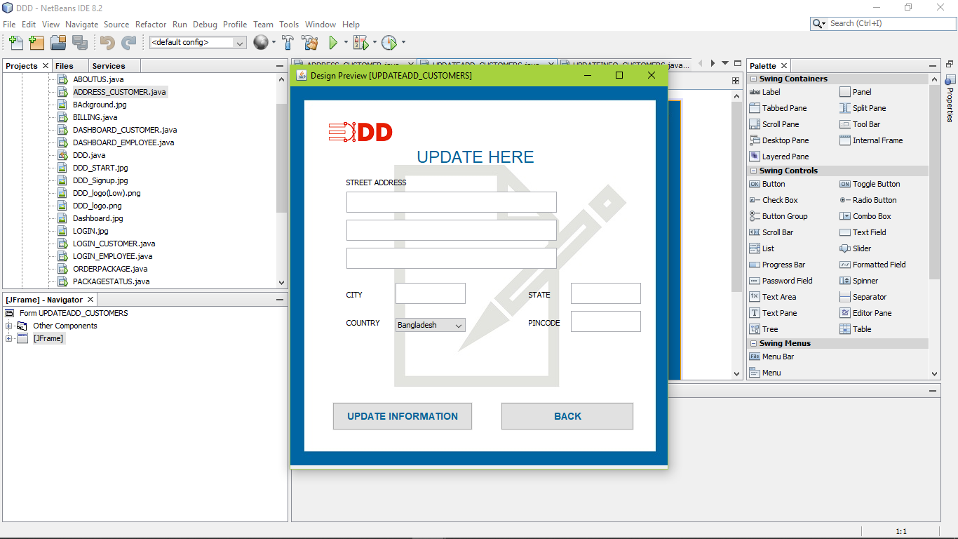

Action Performed (UPDATE ADRESS):

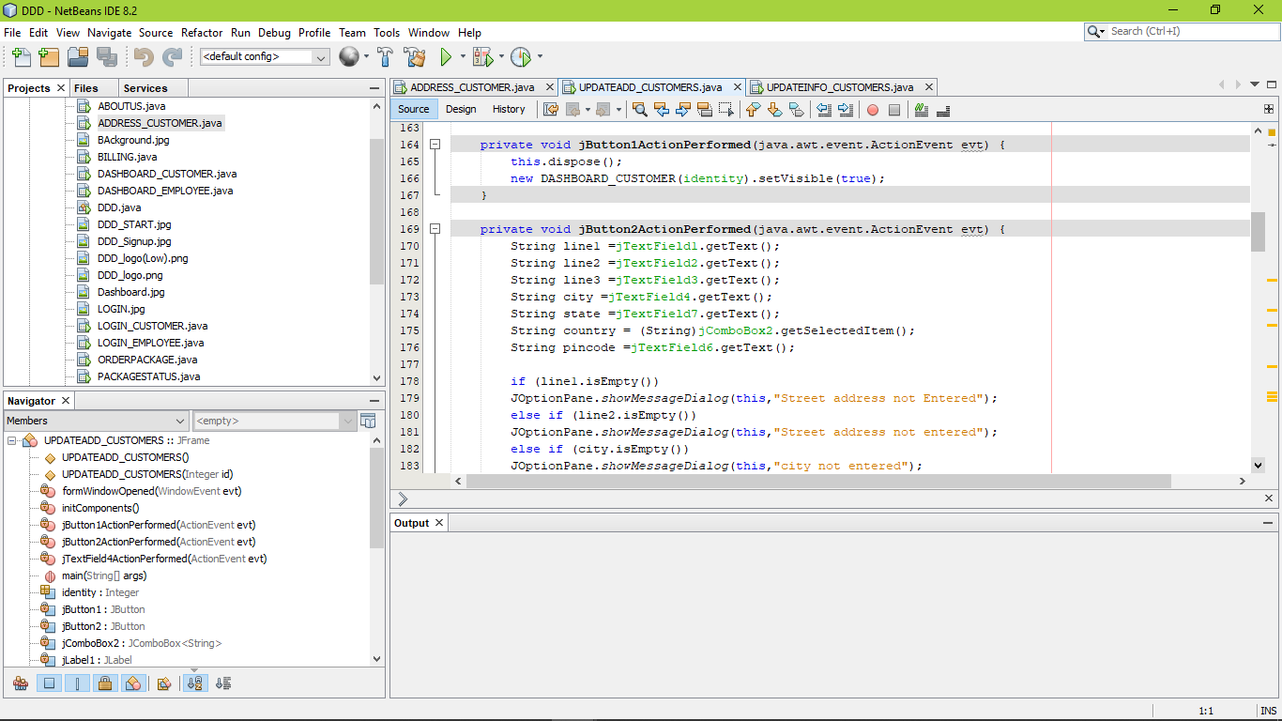

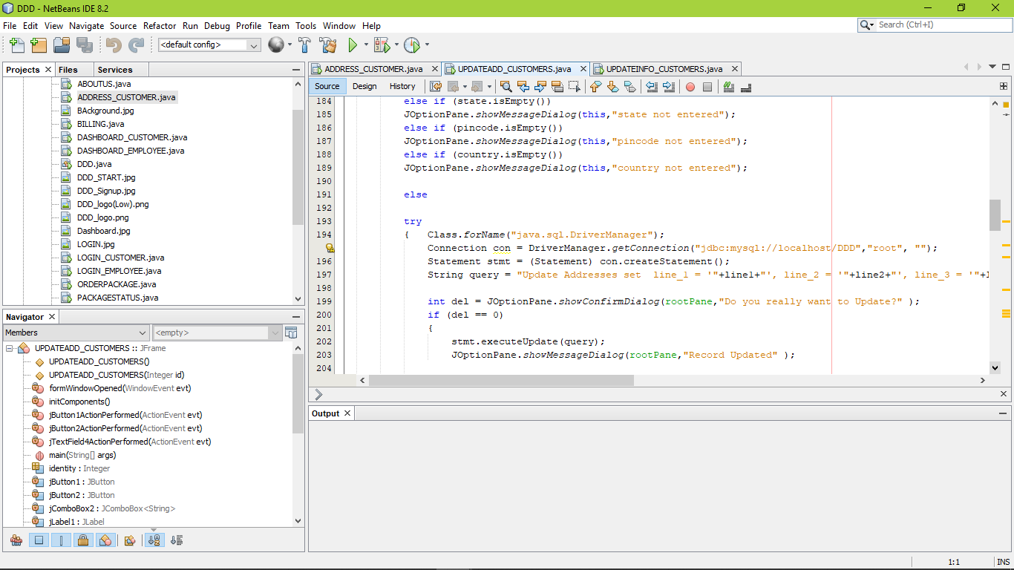

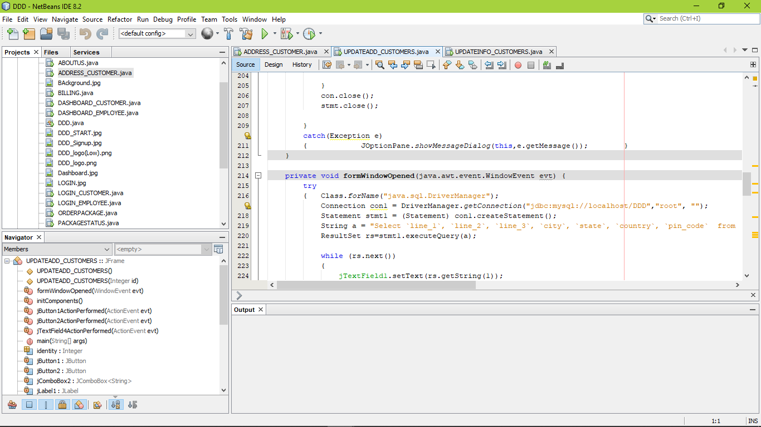

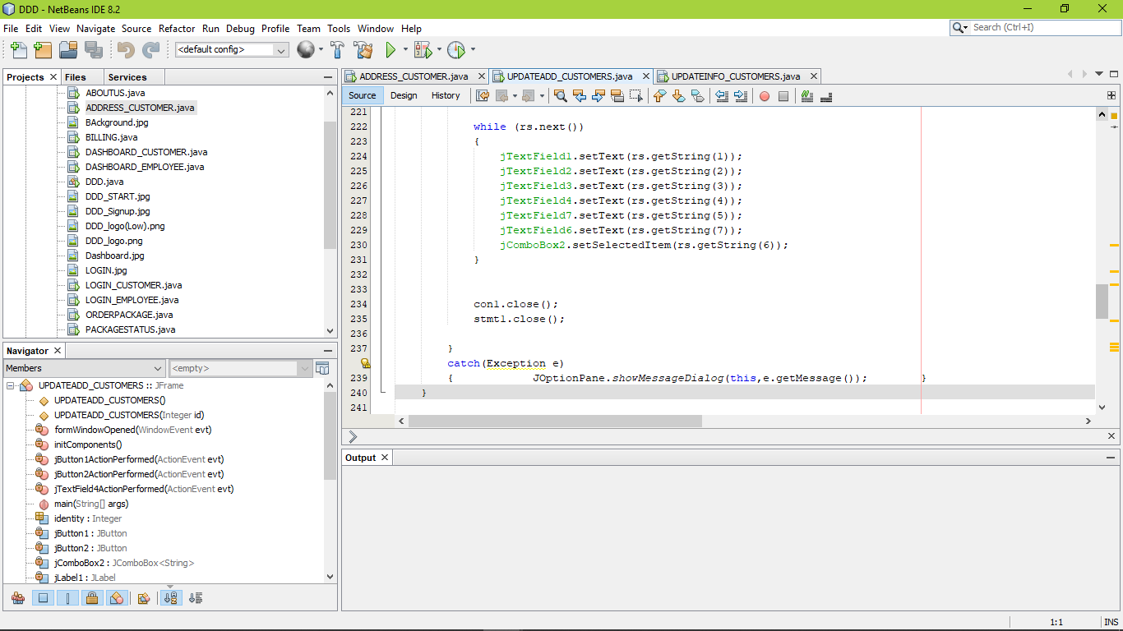

Action Performed (BACK):

Design View (ORDER PACKAGE):

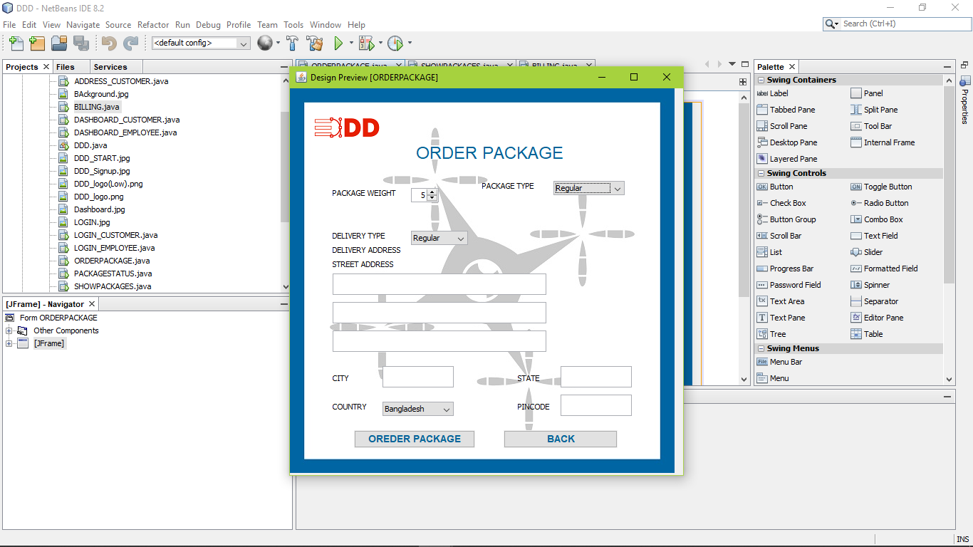

Action Performed (ORDER PACKAGE):

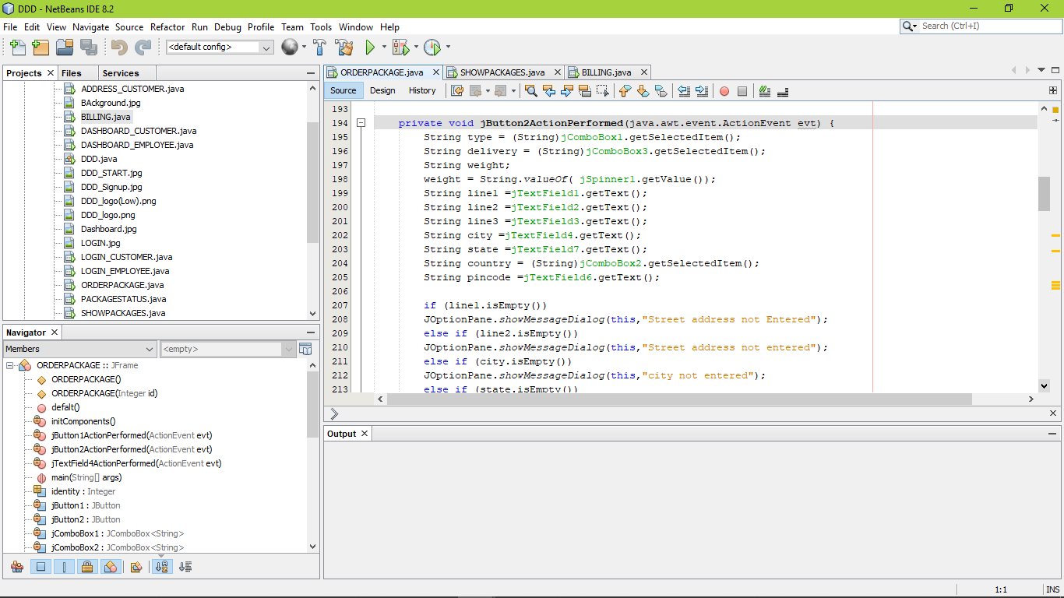

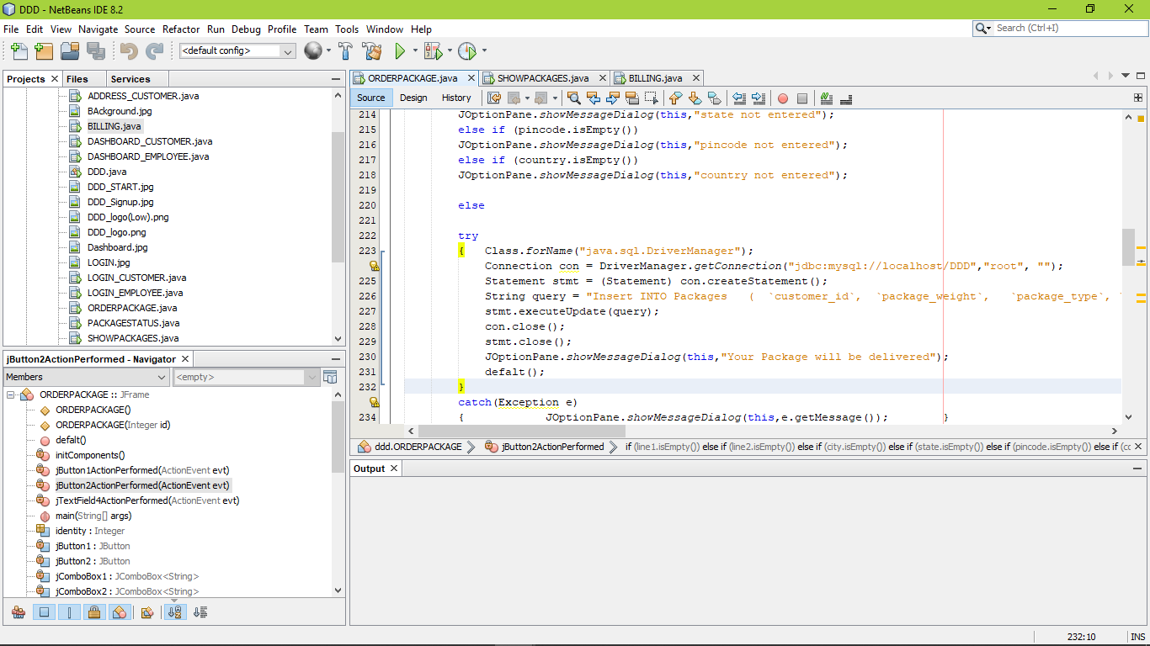

Action Performed (BACK):

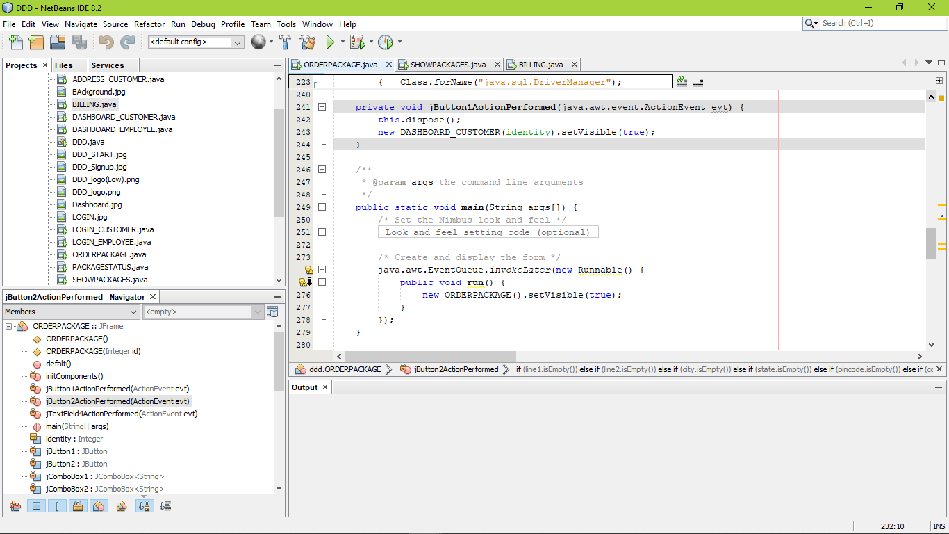

Run View:

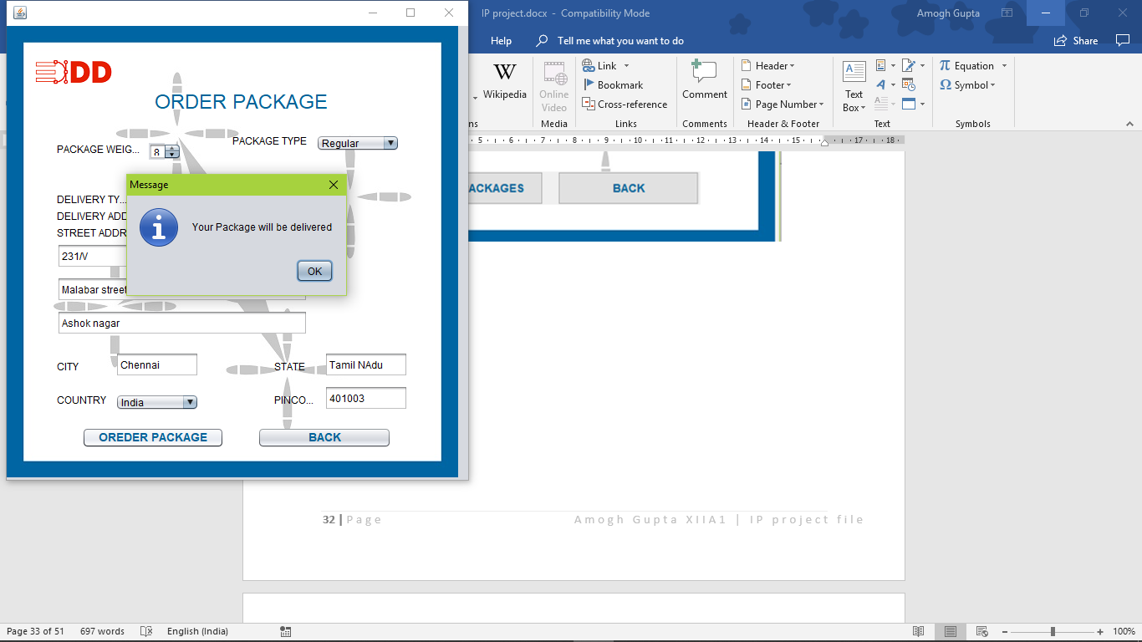

Design View (SHOWPACKAGES):

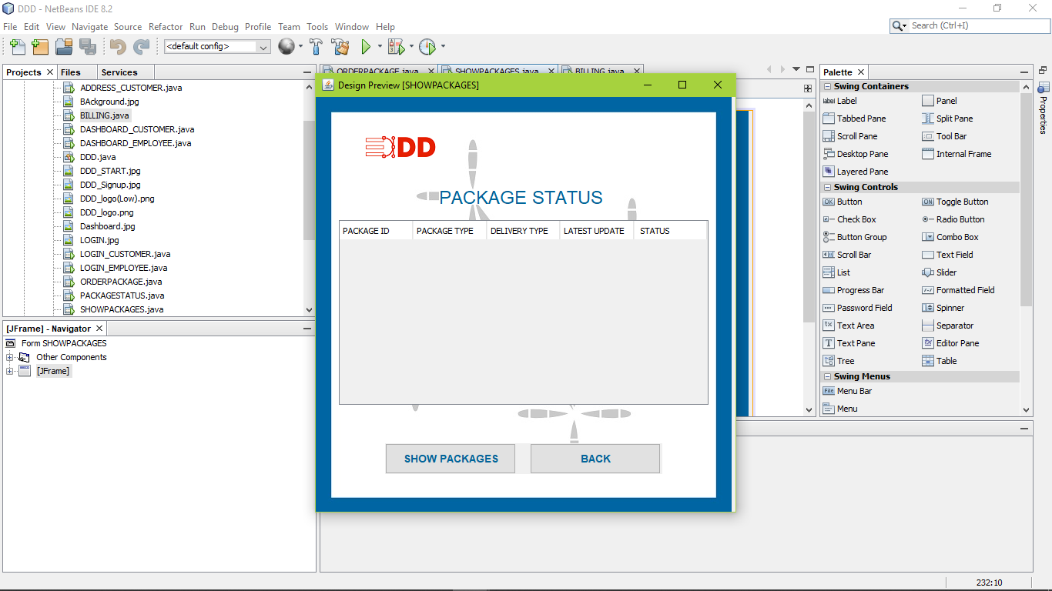

Action Performed (ORDER PACKAGE):

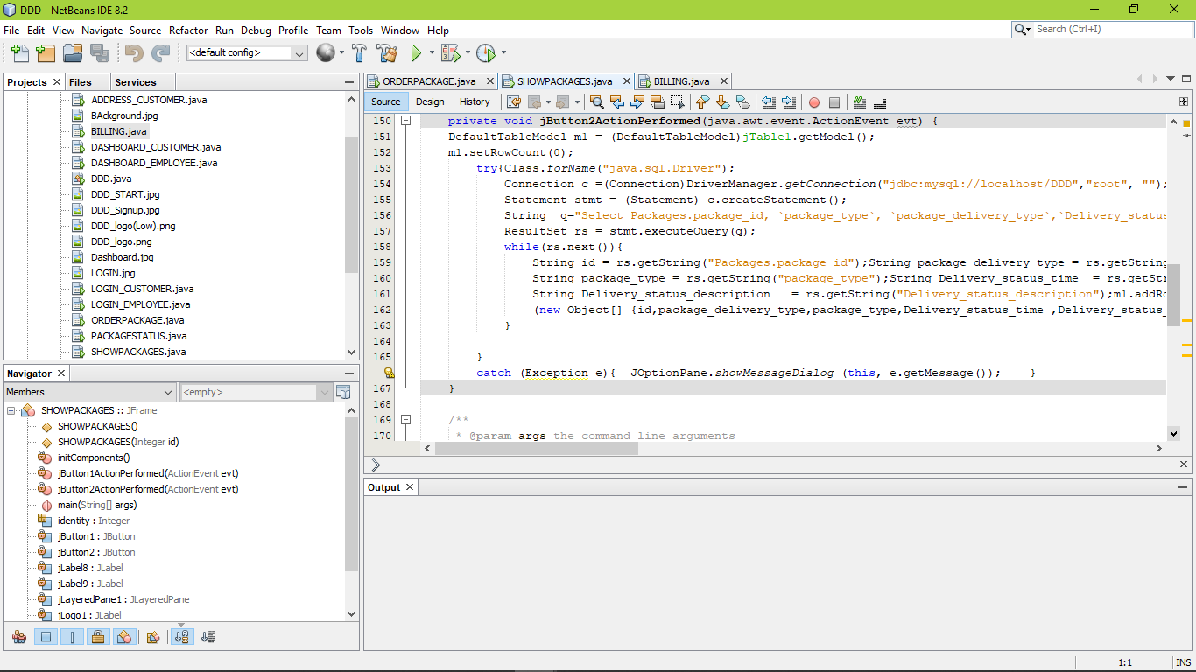 Run View :

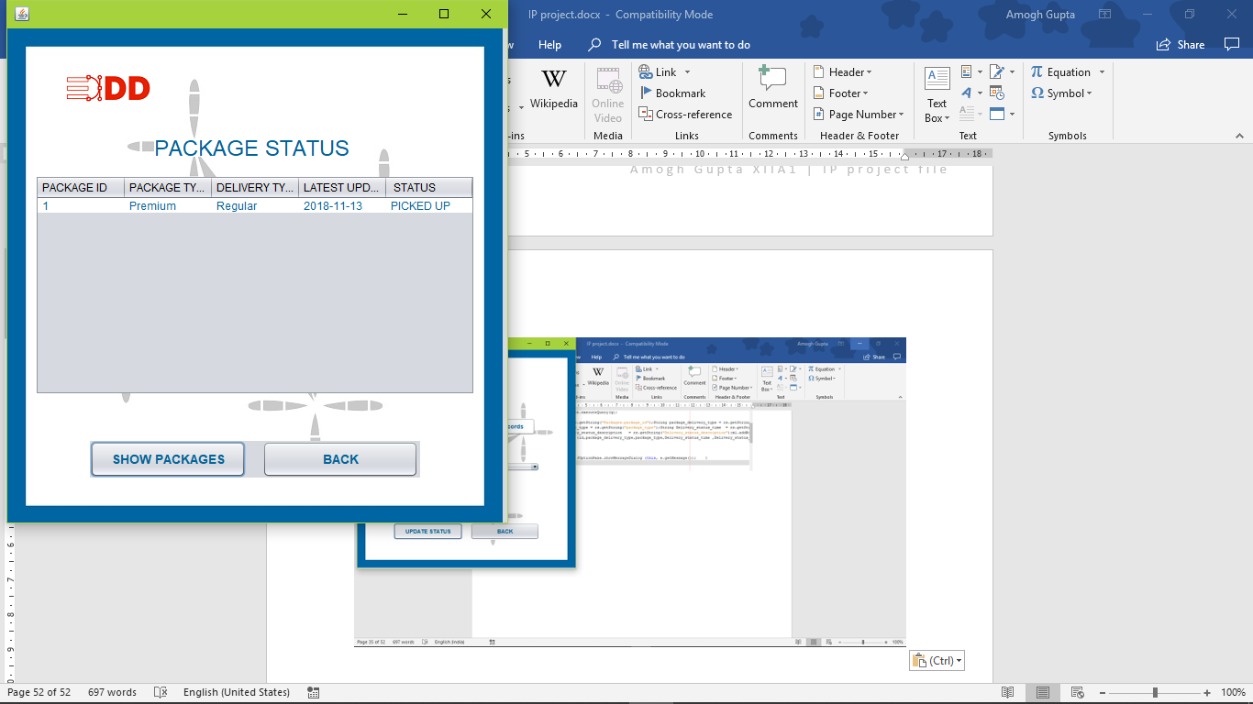

Design View (BILLING):

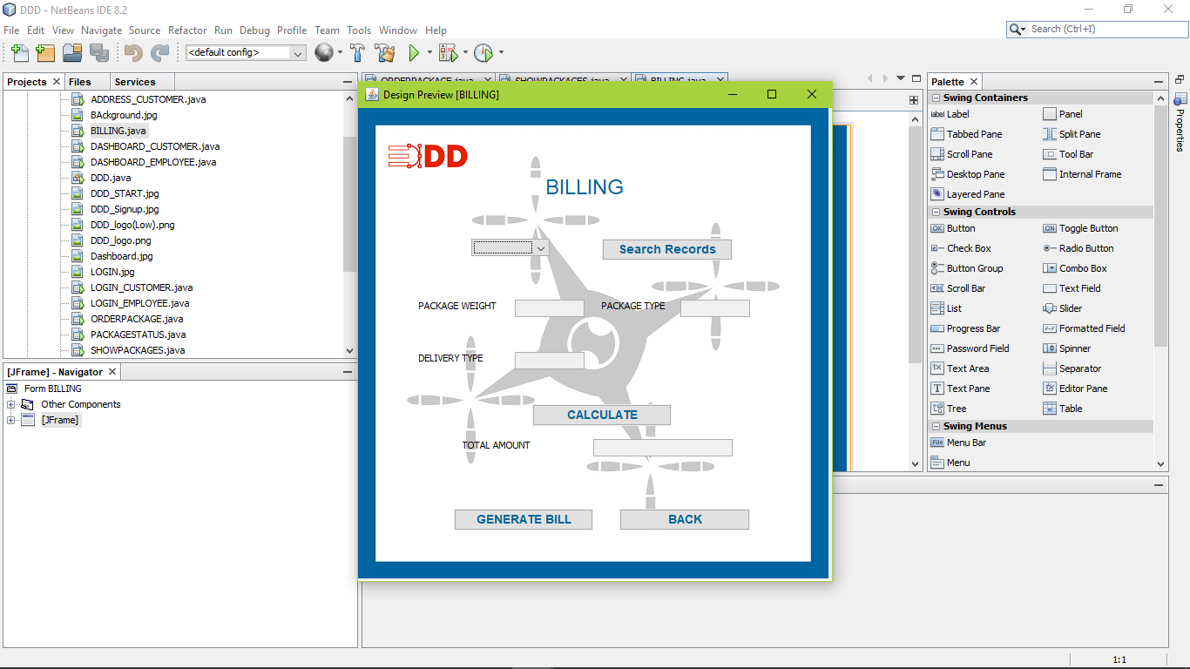

Action Performed (SEARCH RECORDS):

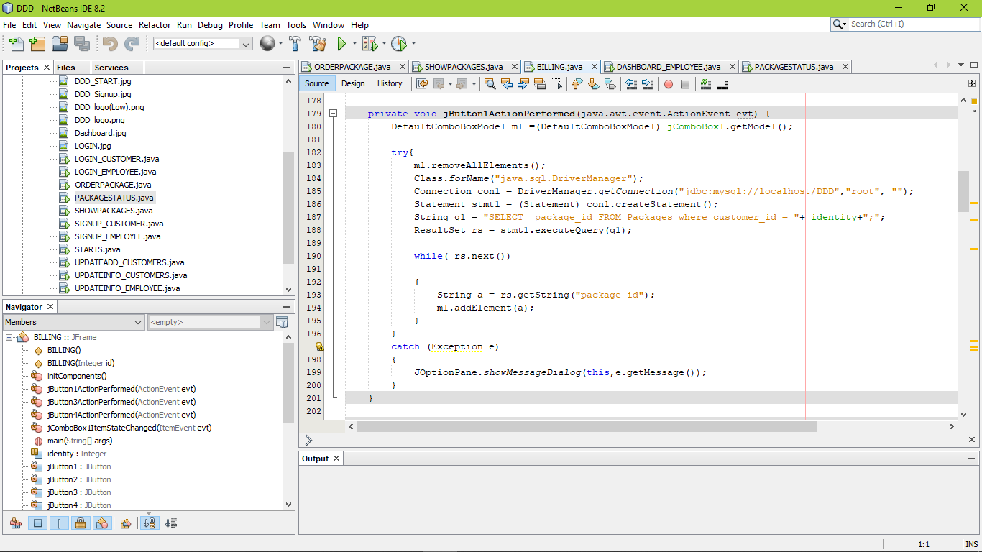

Action Performed (RECORD SELECTED):

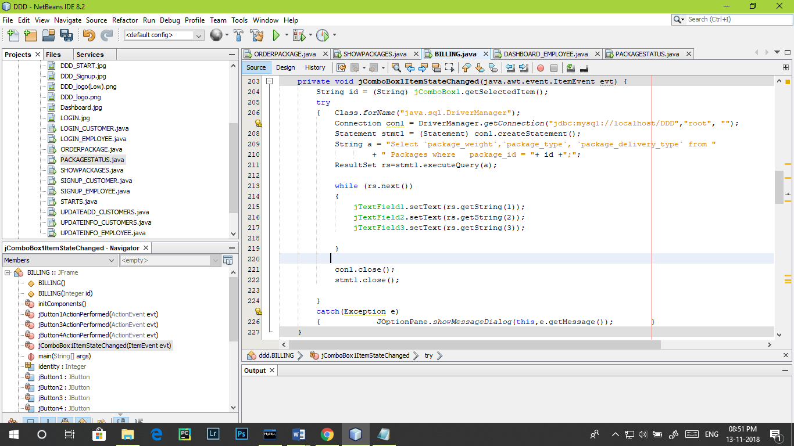

Action Performed (CALCULATE):

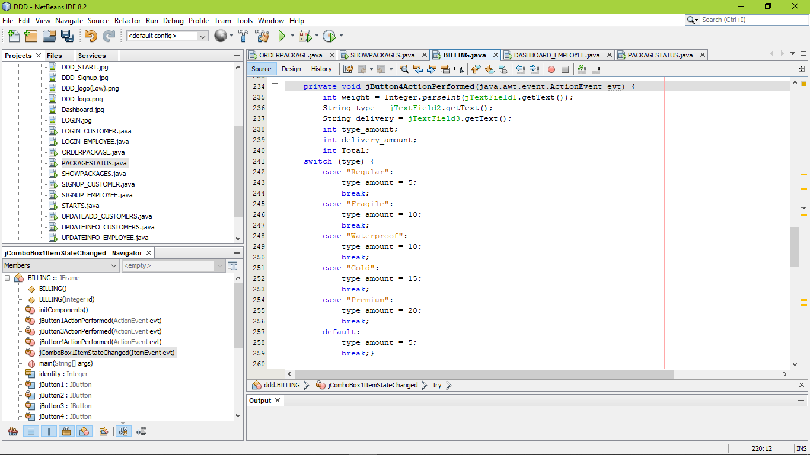

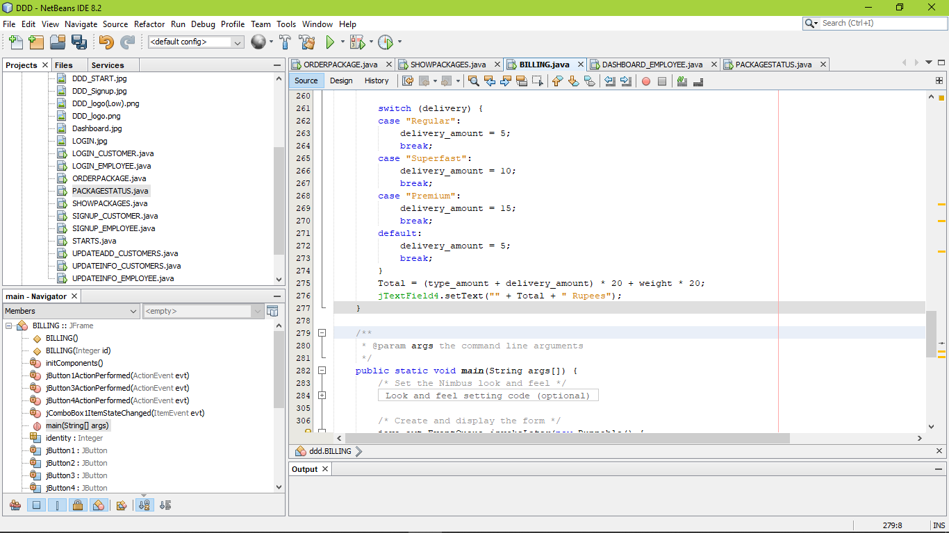

Run View :

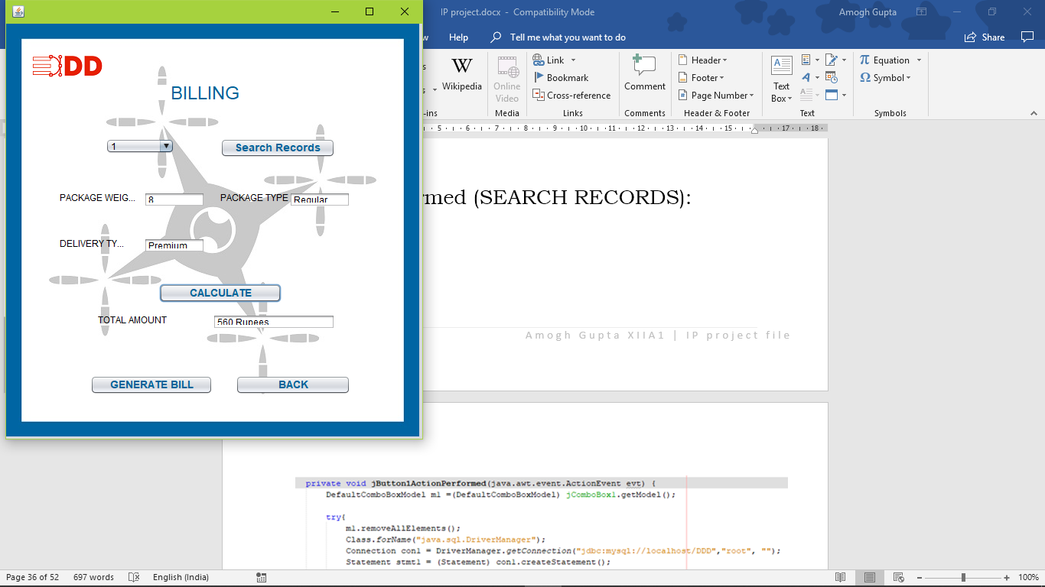

Design View (LOGIN_ EMPLOYEE):

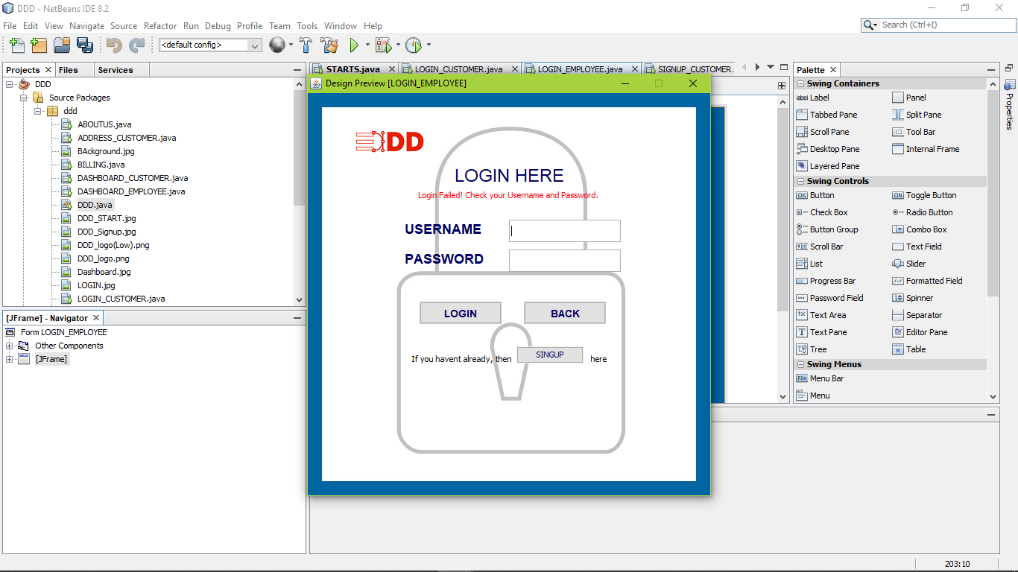

Action Performed (LOGIN):

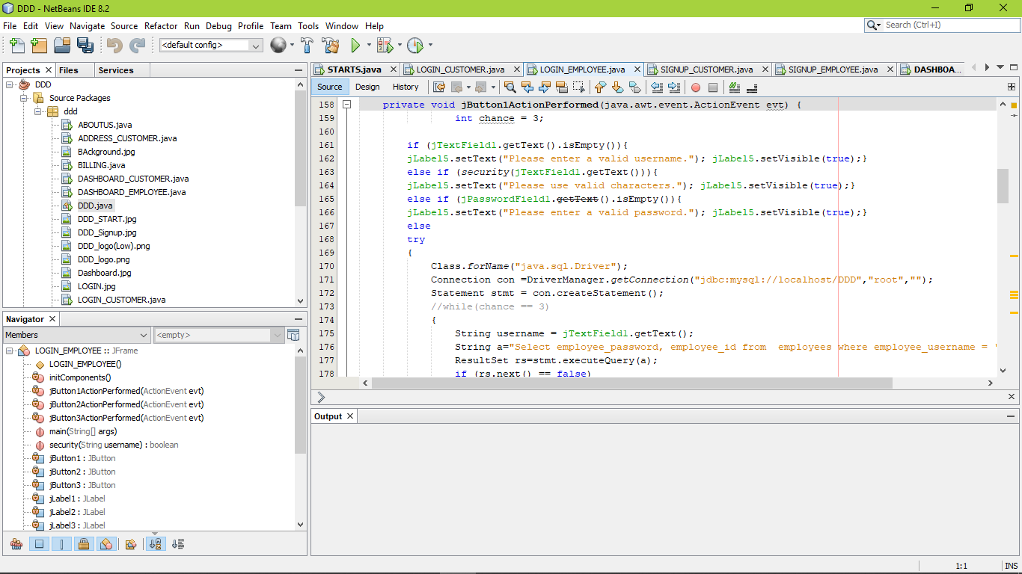

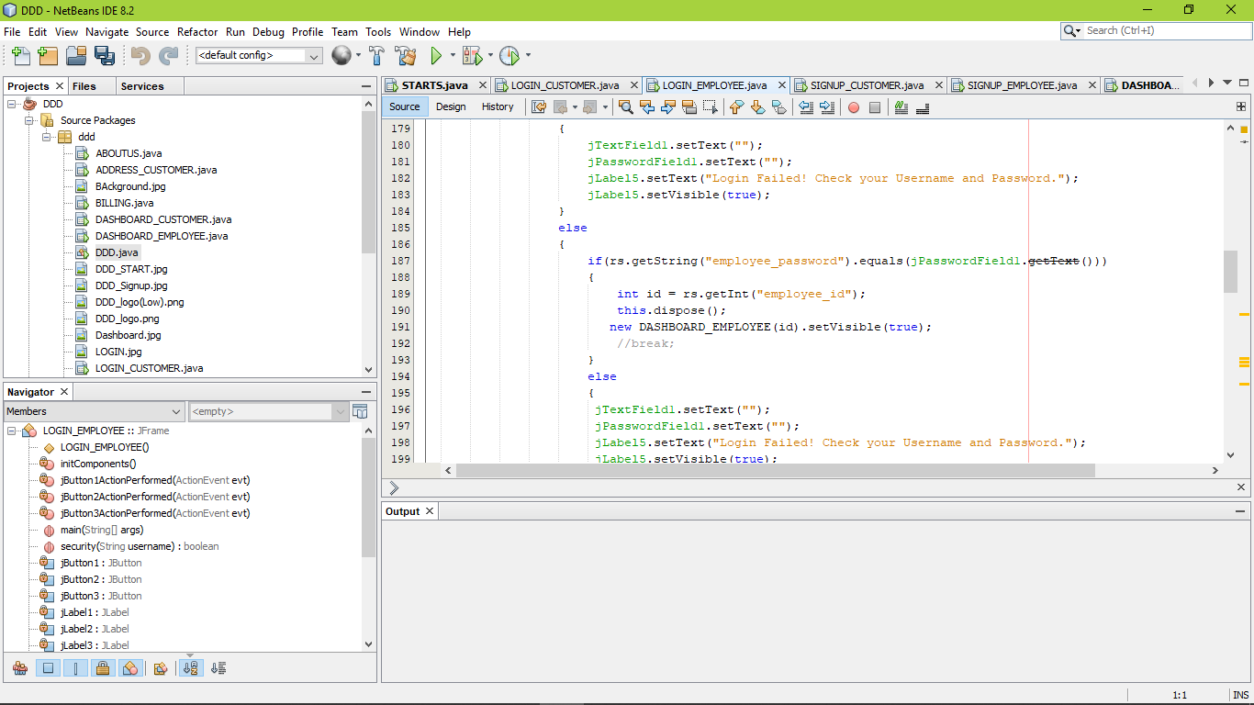

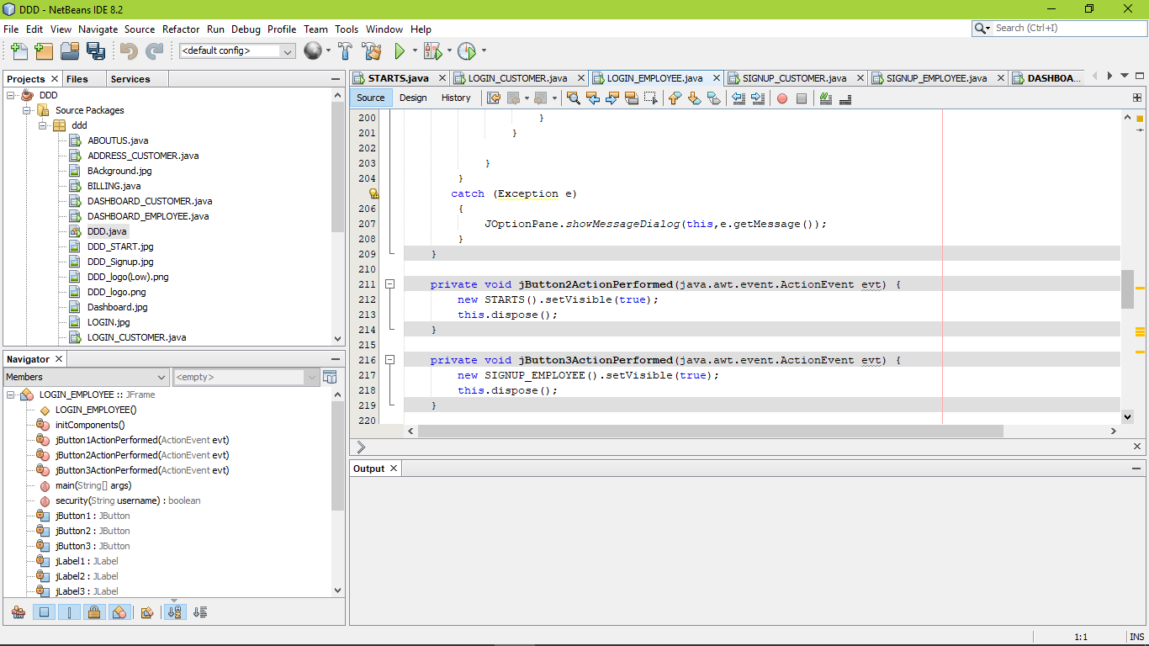

Action Performed (BACK):



Action Performed (SIGN UP):



Design View (SIGN UP EMPLOYEE):

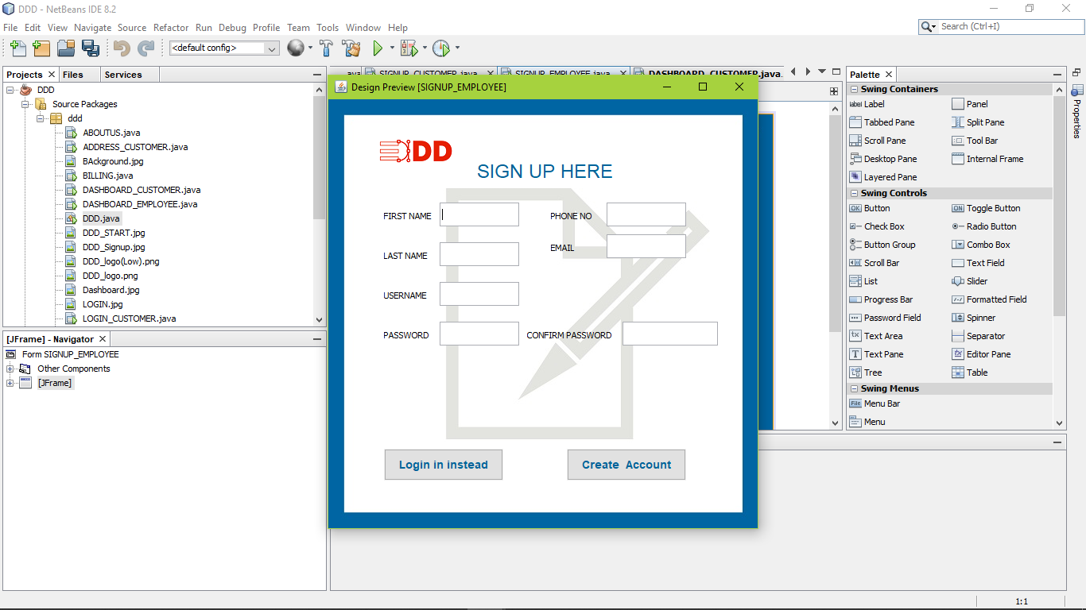

Action Performed (CREATE ACCOUNT):

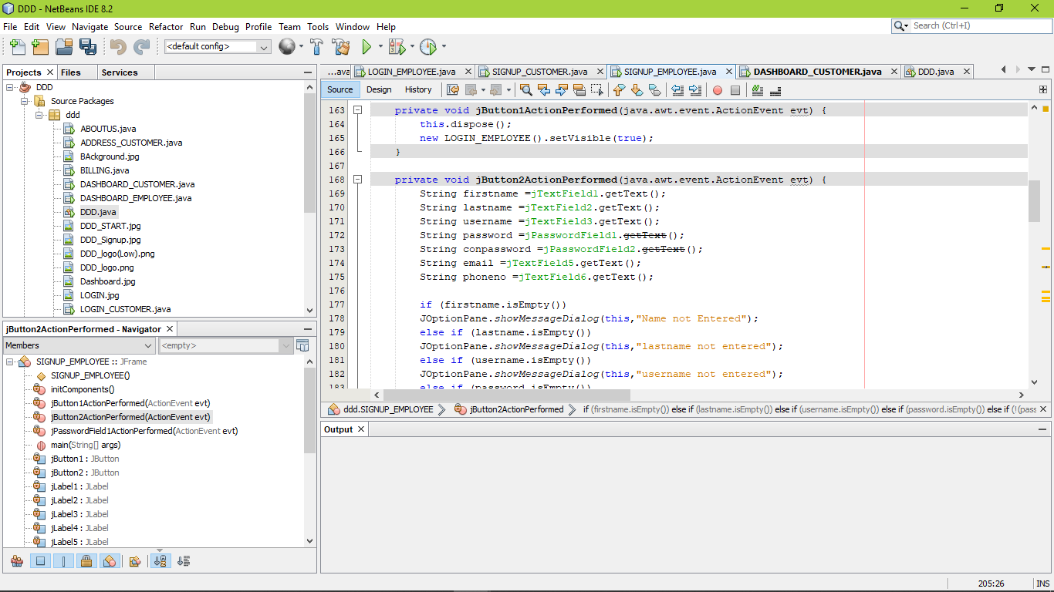

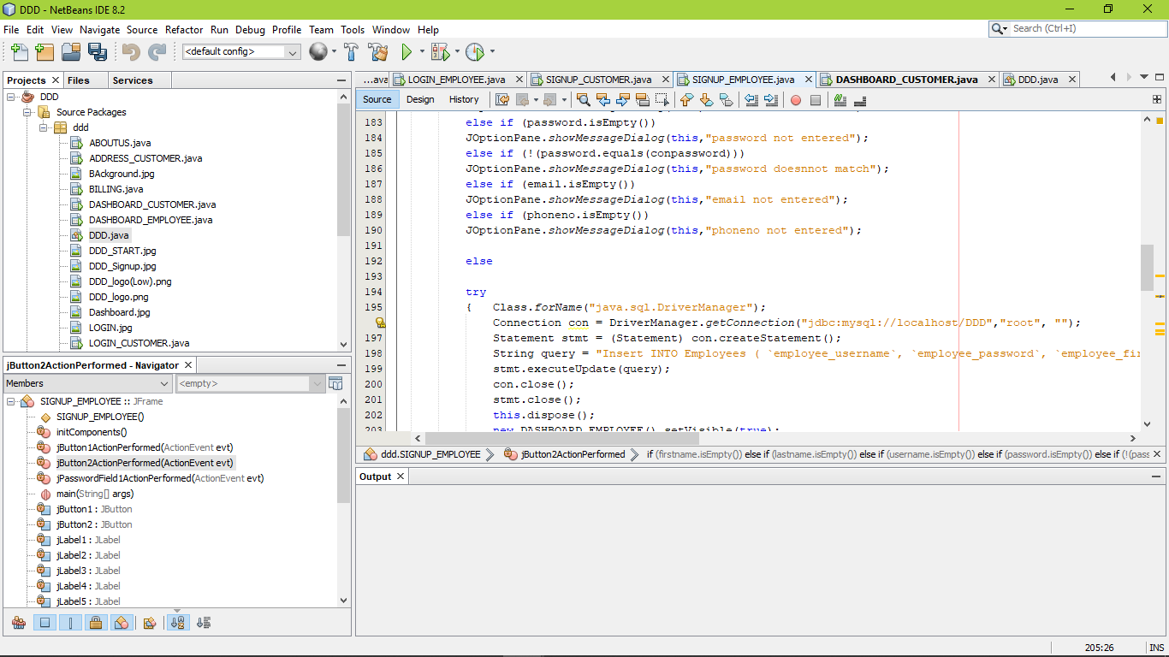 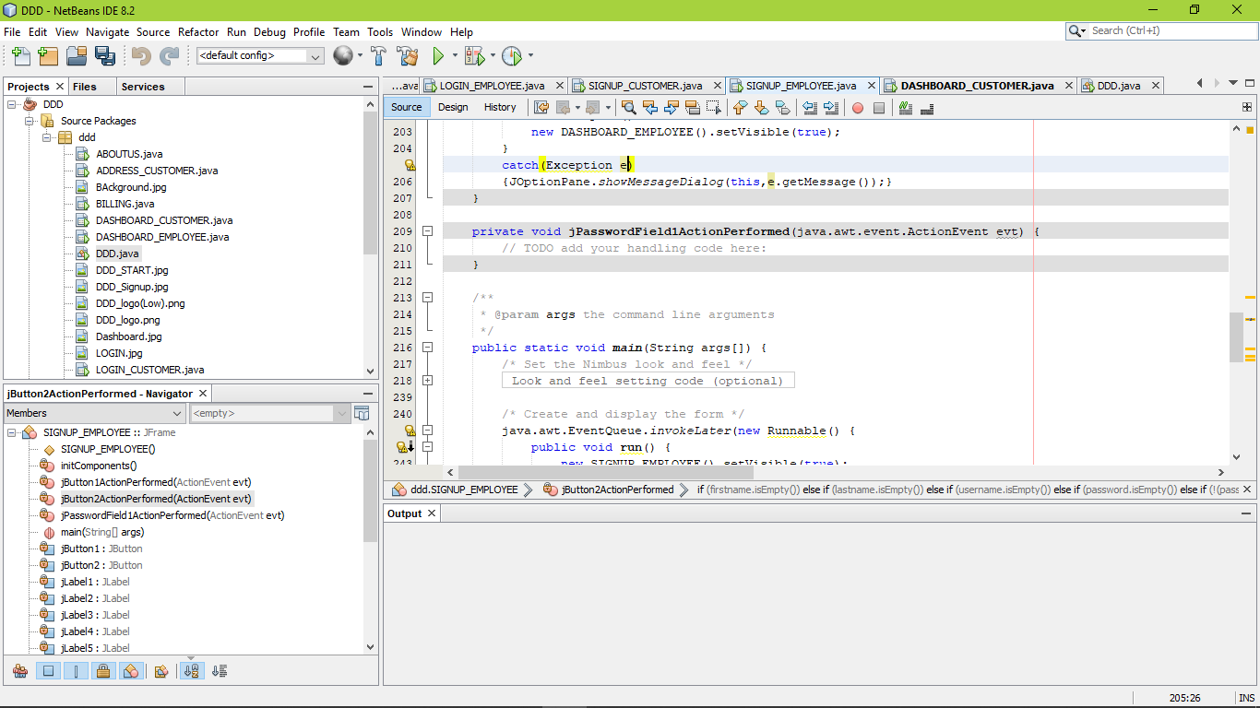

Action Performed (LOGIN INSTEAD):



Design View (DASHBOARD CUSTOMER):

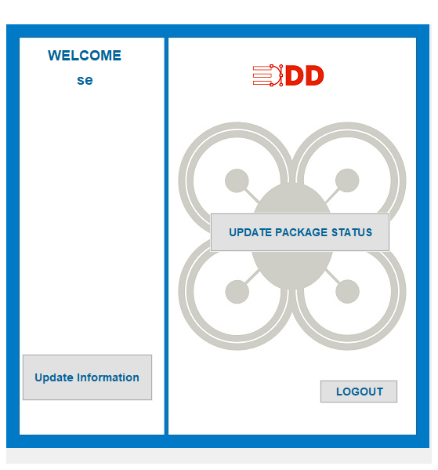

Window Opened (FORM):

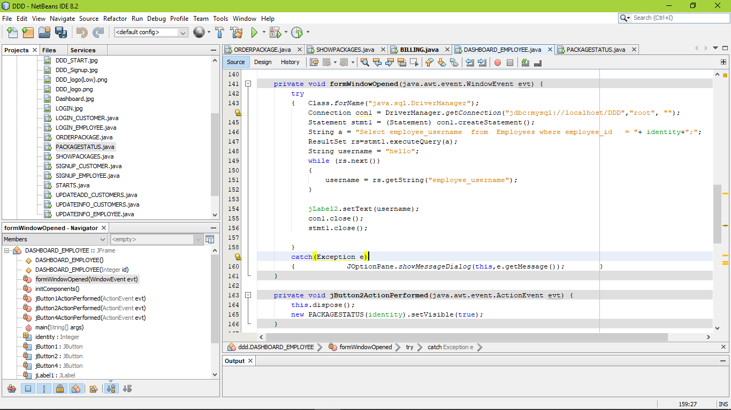

Action Performed (PACKAGE STATUS):

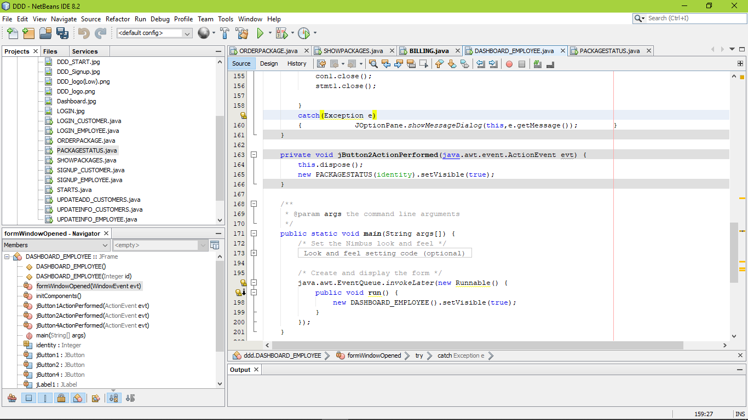

Action Performed (UPDATE INFORMATION):

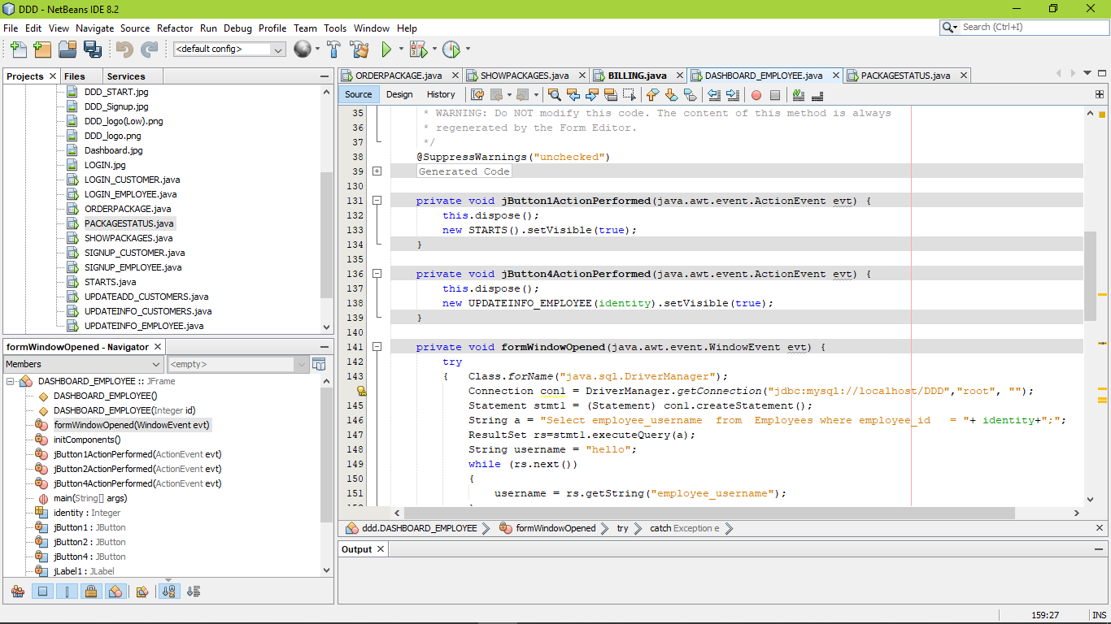

Action Performed (LOGOUT):



Run View:

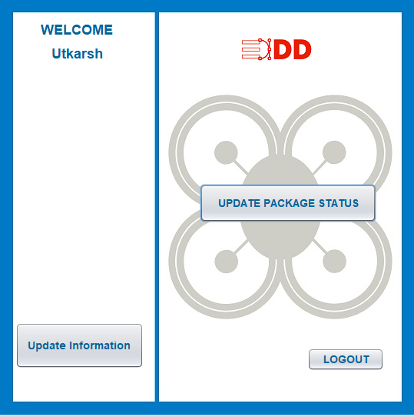

Design View (UPDATEINFO_EMPLOYEE):



Action Performed (UPDATE INFORMATION):

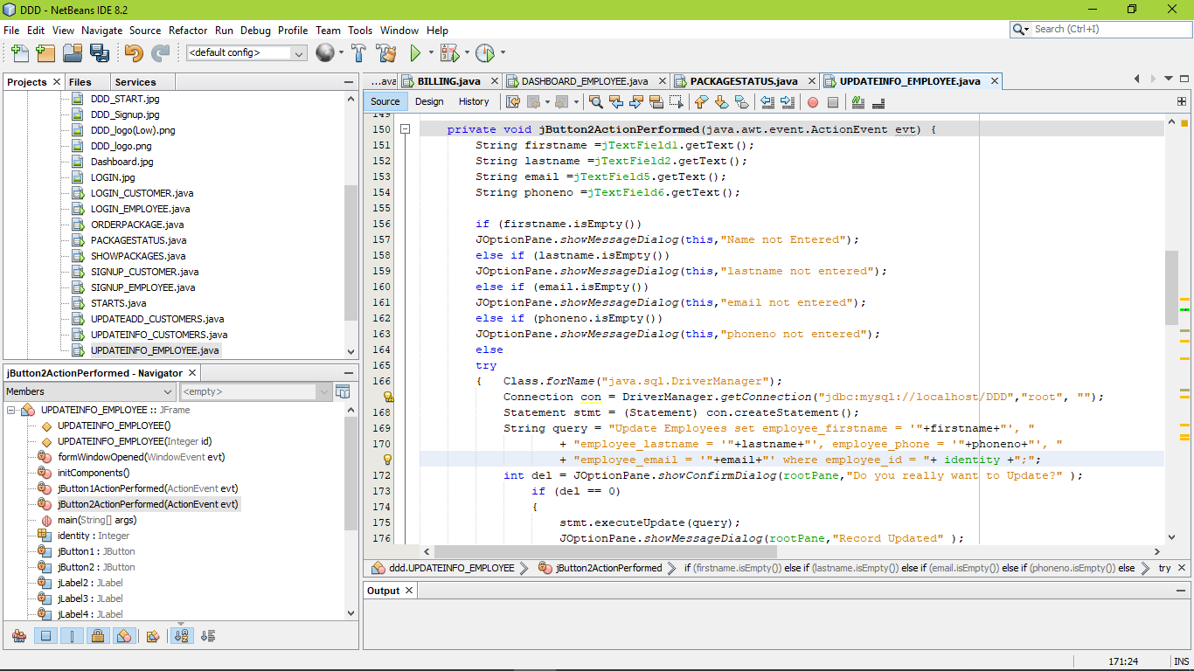

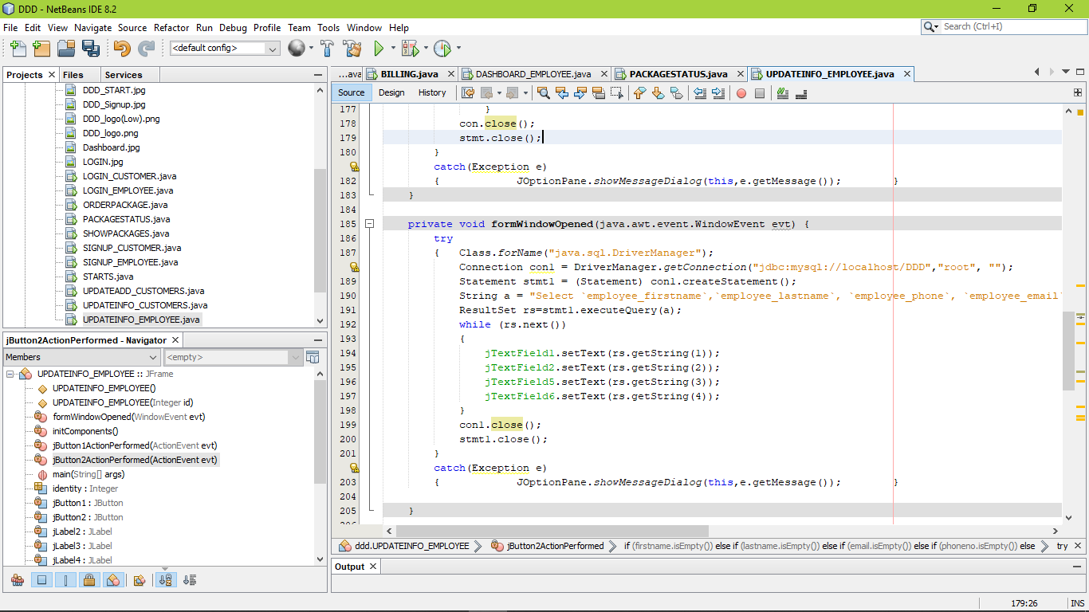

Action Performed (BACK):

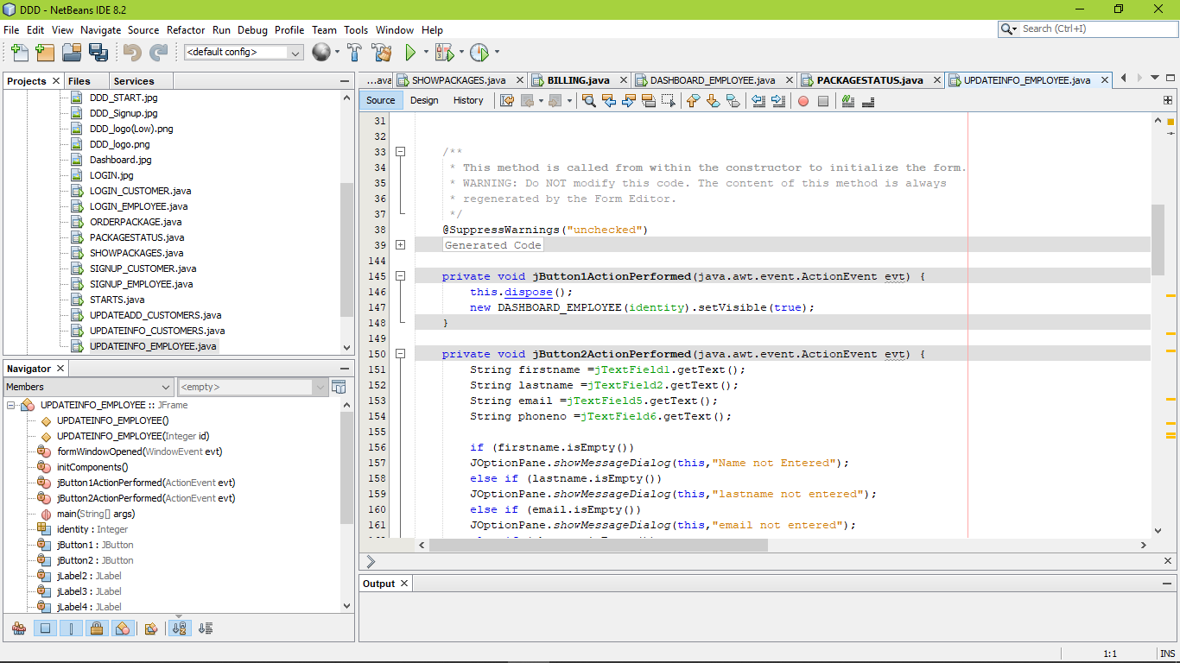

Design View (PACKAGE STATUS):

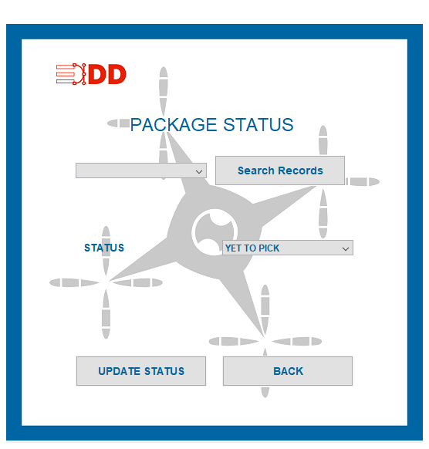

Action Performed (SEARCH RECORDS):

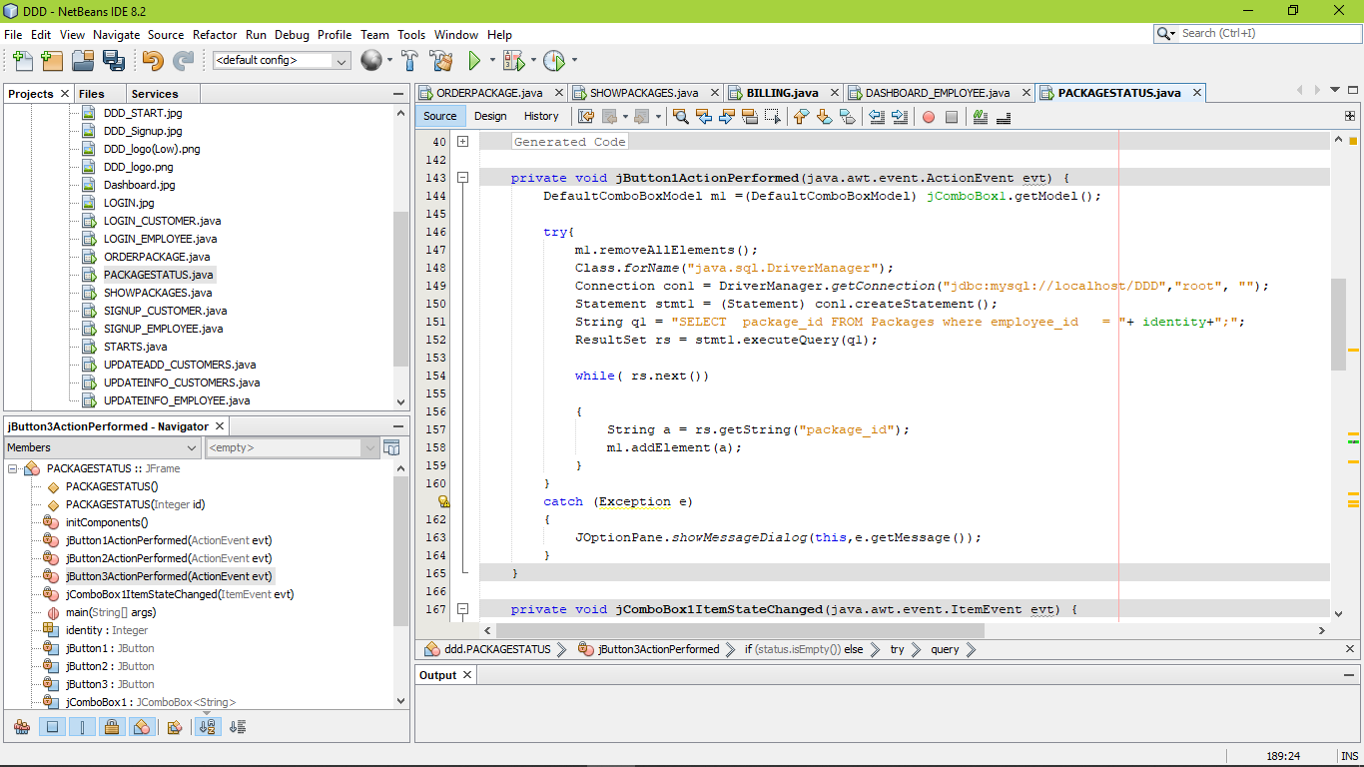

Action Performed (UPDATE STATUS):

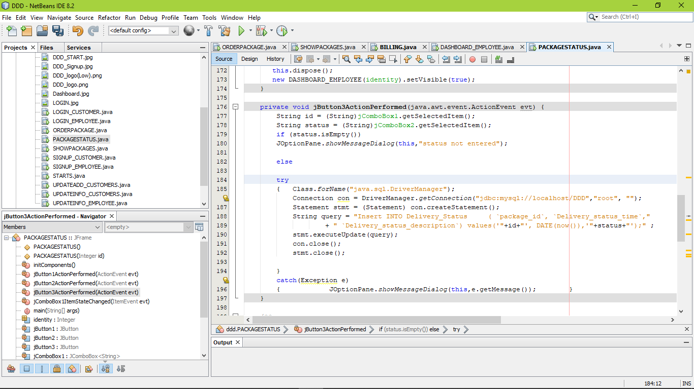

Run View :

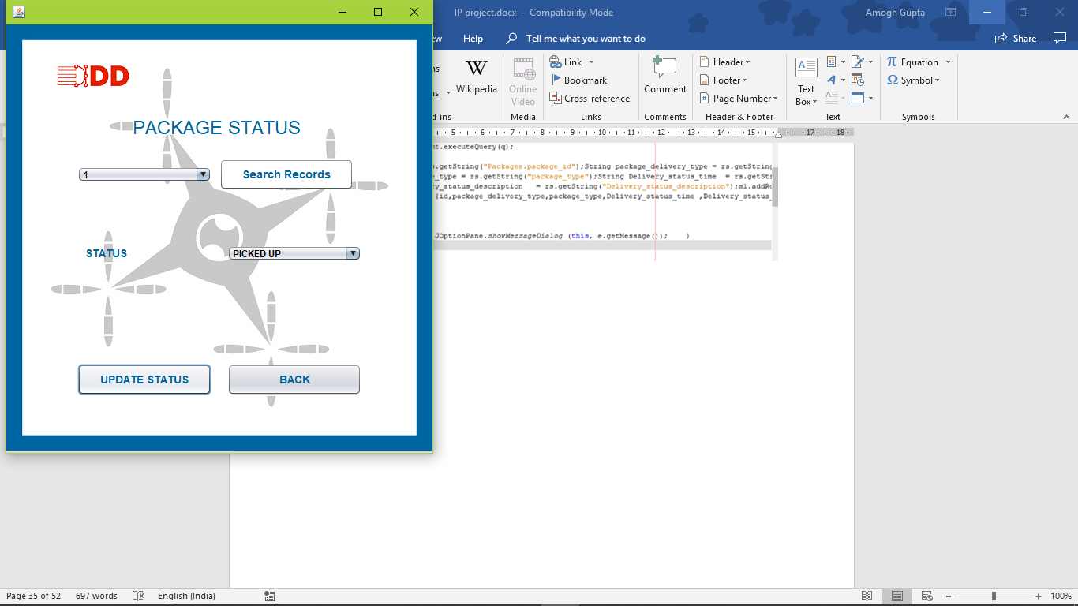

Bibliography

* CLASS ROOM NOTES.
* INFORMATICS PRACTICES BOOK (CBSE PUBLICATION)
* Adobe Spark
* W3School.com